**UNIX - OPERATING SYSTEM**

**----- (ARUN SIR) ADAPA GANESH**

**Today(01/09/2020):**

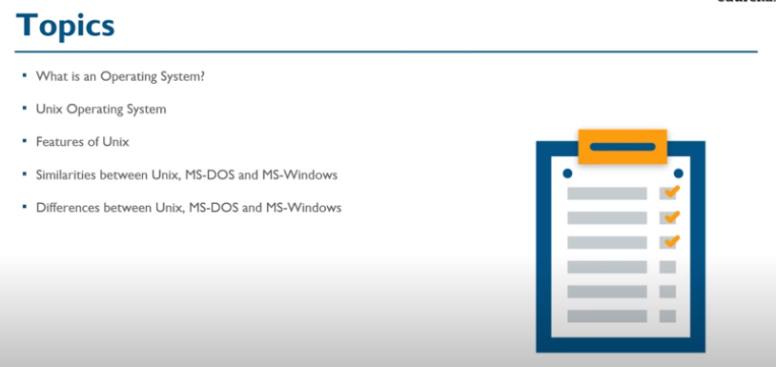

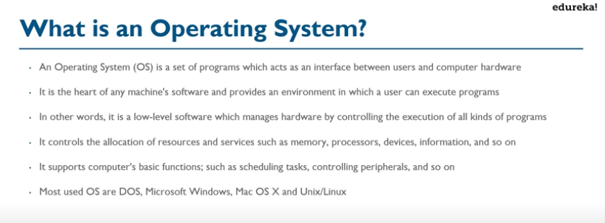

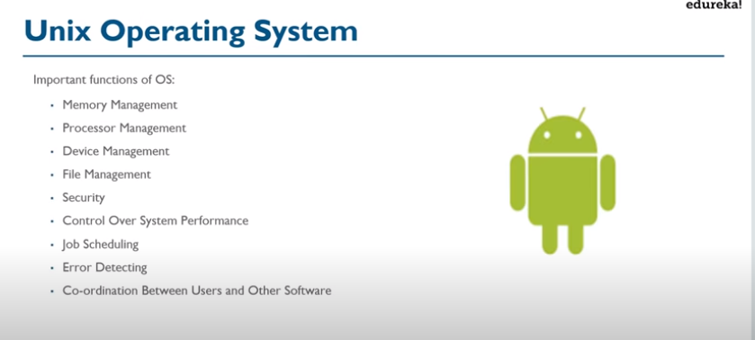

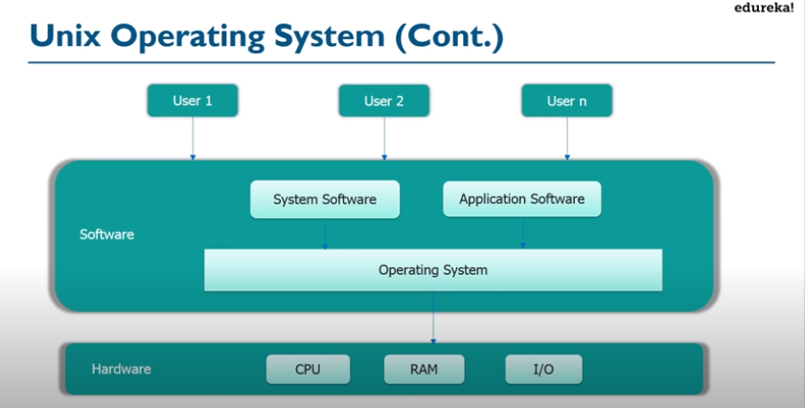

American Telephone & Telegraph Company

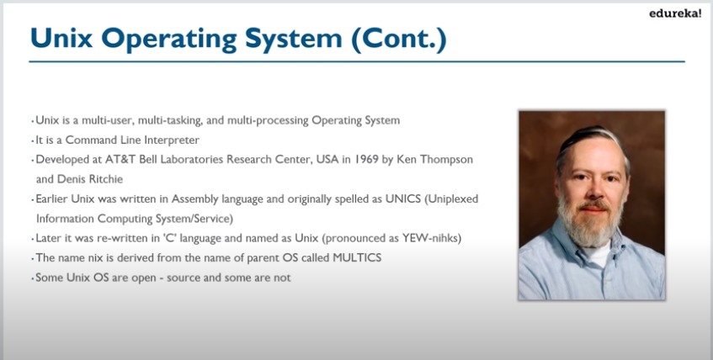

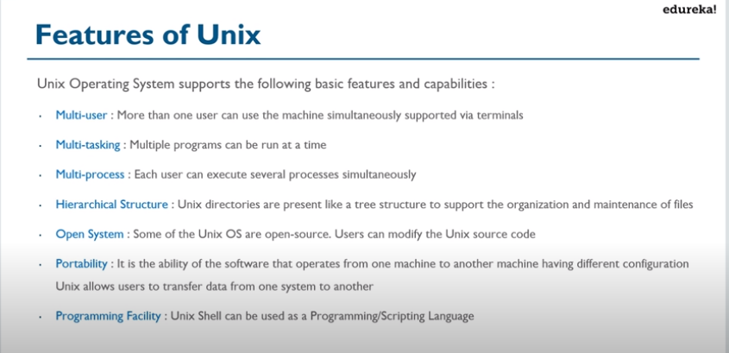

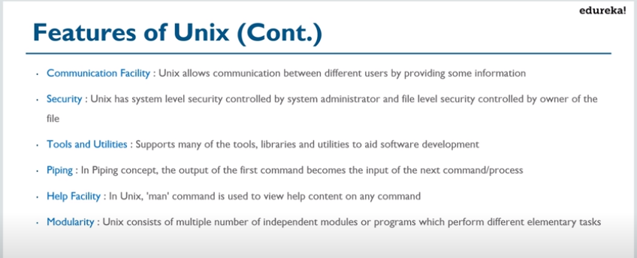

**DOS:**DOS (Disk Operating System) are simple text command operating systems that were popular from 1981 to 1995.DOS used a text based interface that required text and codes to operate.Text is used as the basic input system commands.DOS is unable to run multiple processes at the same time.The highest amount of storage size available is 2GB.Booting up system is DOS is less demanding on the CPU.DOS uses a directory system, where all the files are contained within a particular directory or a subdirectory.More ideally used for prototyping, testing, and making automated systems.DOS is free.

**Windows:**Windows is a range of graphical interface operating systems that are developed and sold by Microsoft.Windows uses graphics, images and text.Uses a mouse for all operating system input.Windows is a multitasking operating system; allowing more than one process to work simultaneously.Window systems offer storage space up to 2 terabyte.Booting up Windows is more demanding on the CPU.Windows uses a different registry compared to DOS, making it difficult to manually delete programs. An excessive number of temporary files and file fragments can cause the system to slow down or crash.Used worldwide as the most popular operating system.Windows is costly.

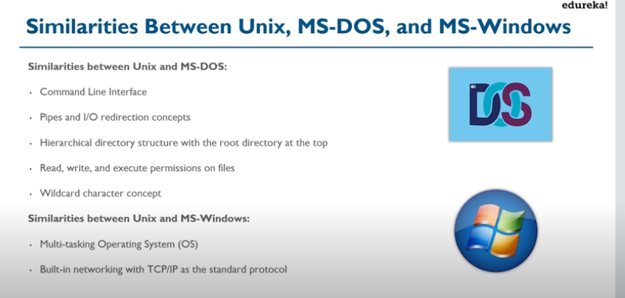

TCP works at the Transport Layer or Layer 4. This Layer is responsible for mainly guaranteed end to end delivery and error correction. Before they can do this though, they need to know where to go.

IP works at the Network Layer or Layer 3. This Layer is responsible for mainly determining the best path to get from Host A to Host B and detecting and rerouting traffic around any failures.

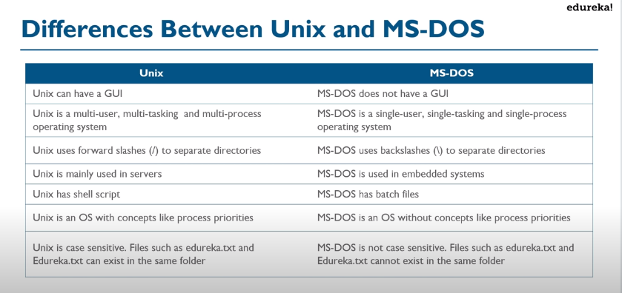

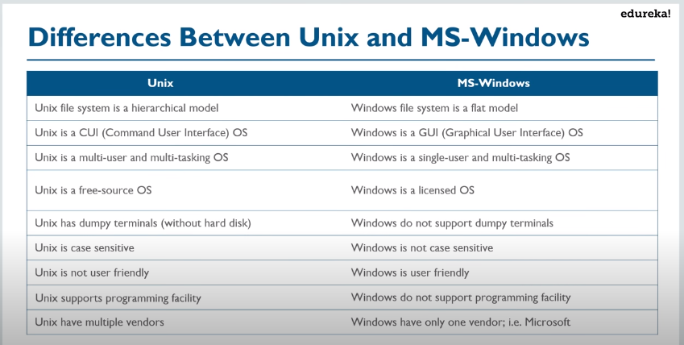

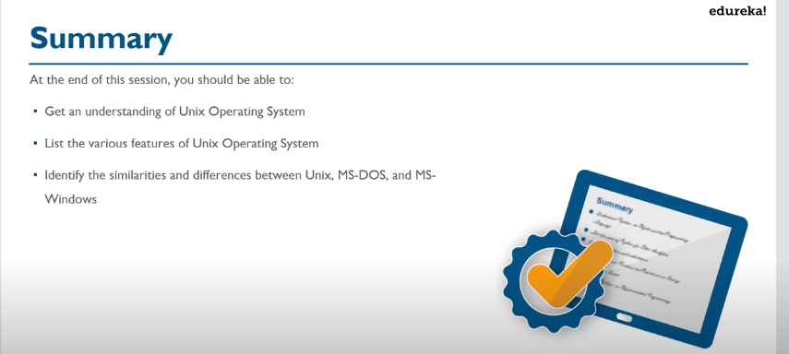

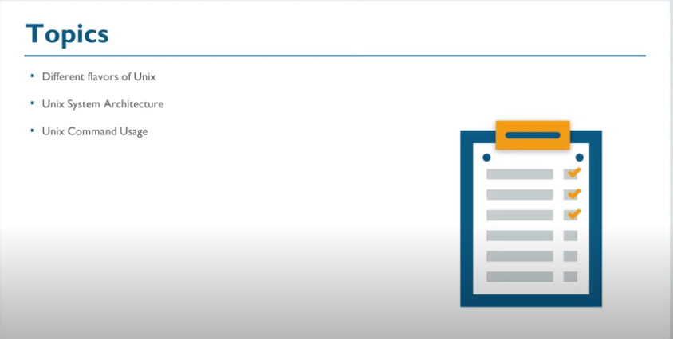S

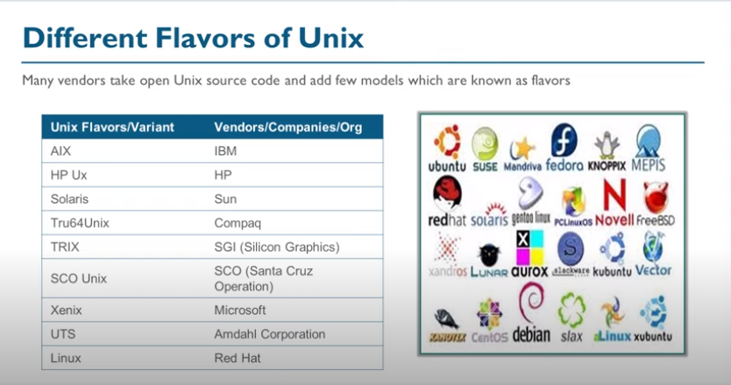

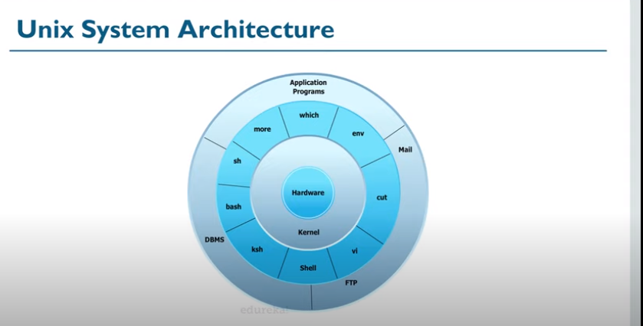

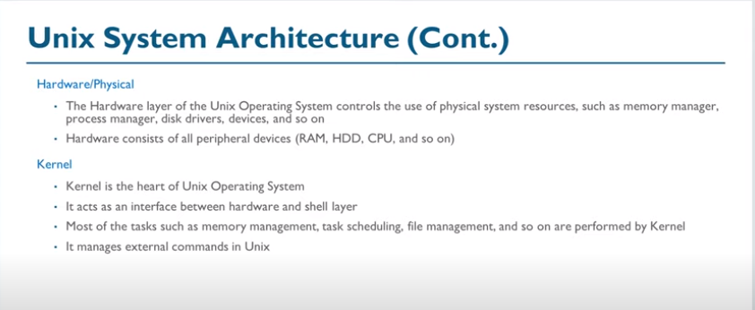

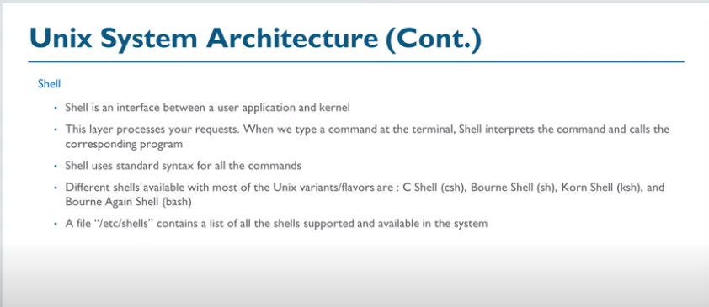

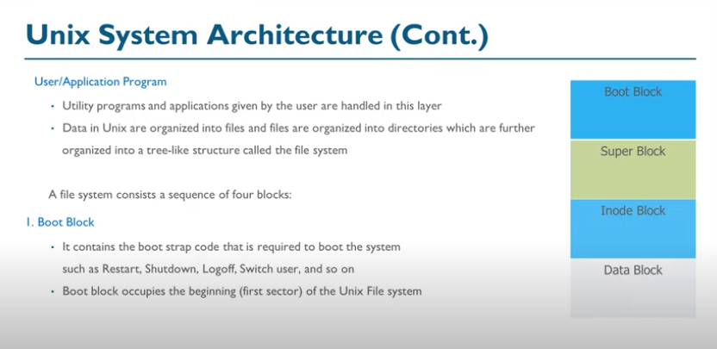

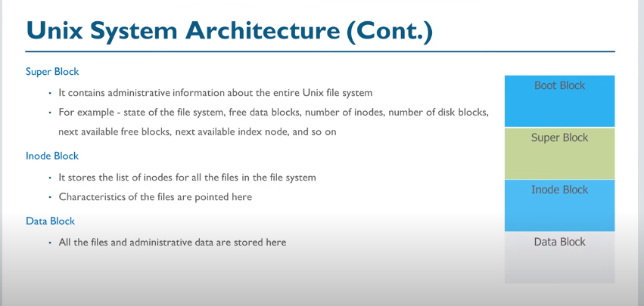

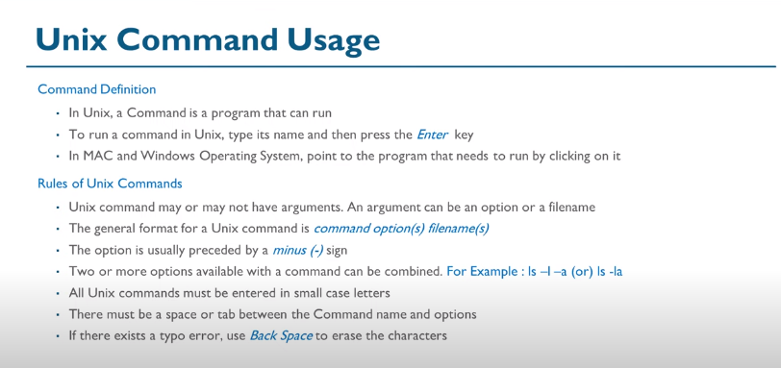

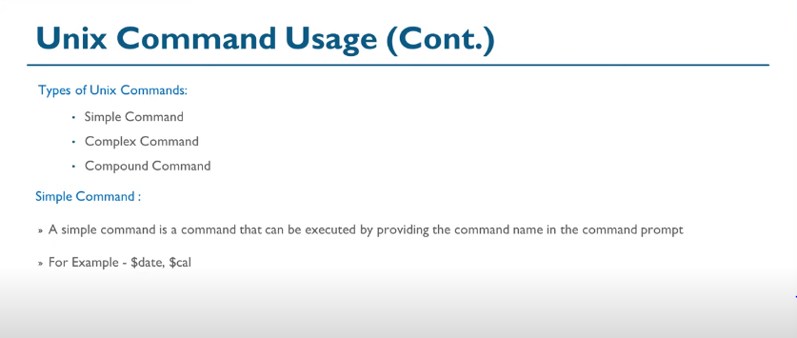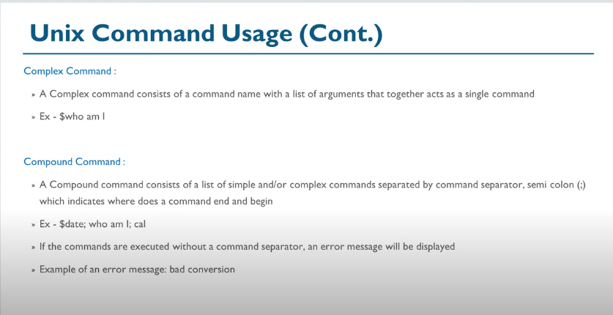

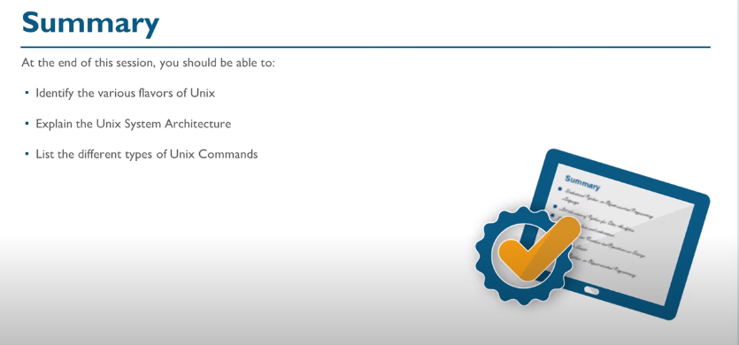

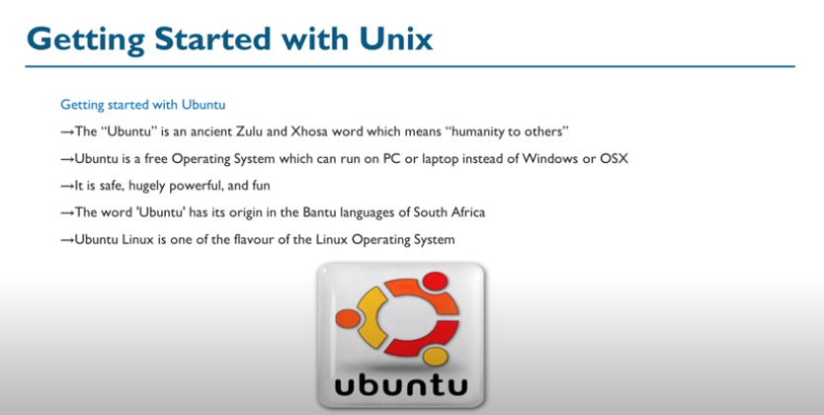

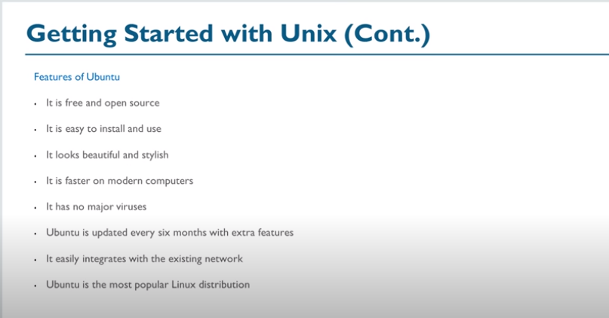

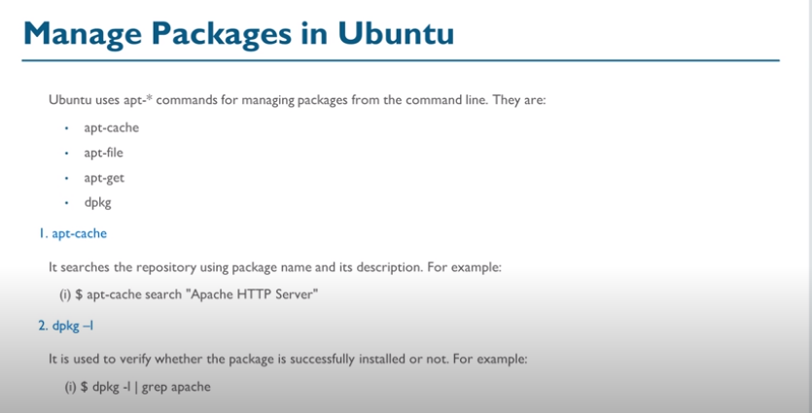

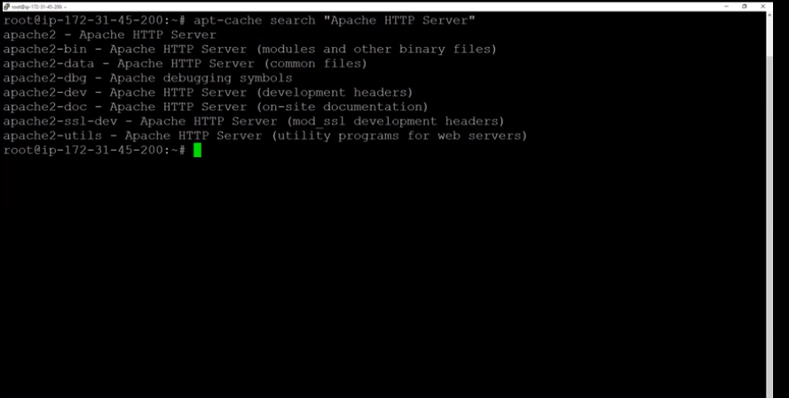

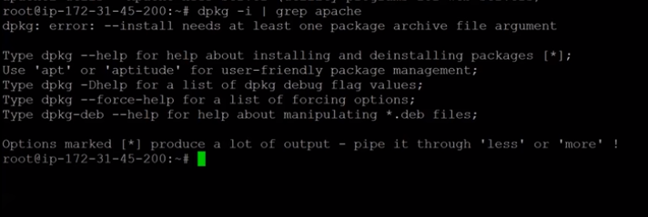

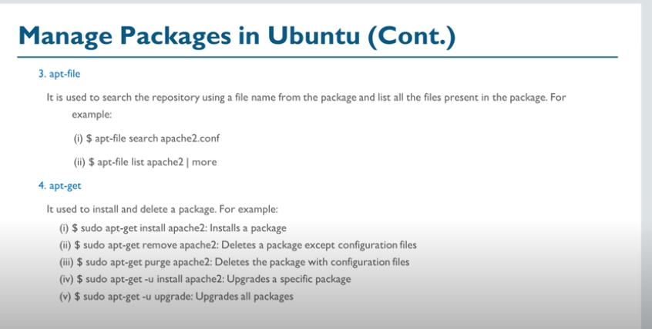

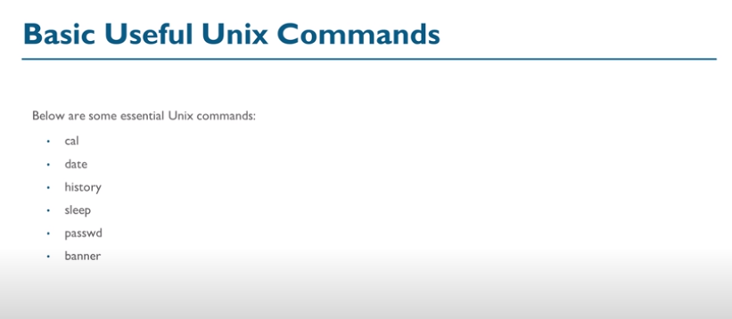

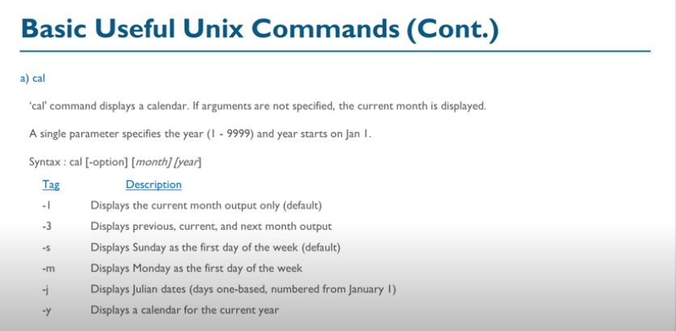

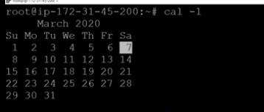

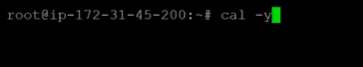

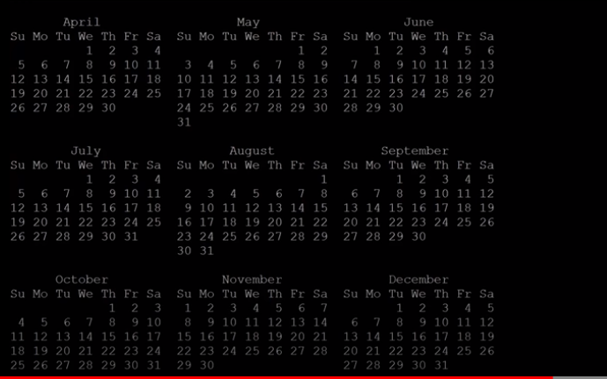

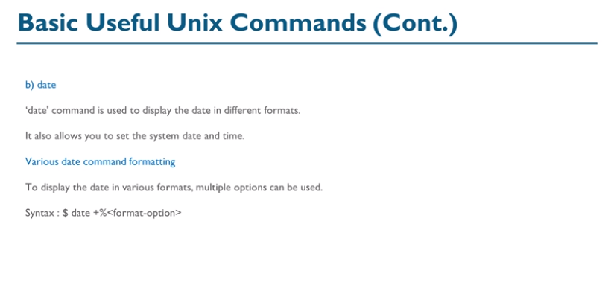

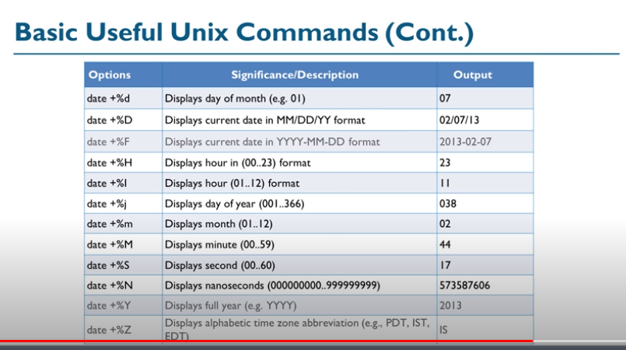

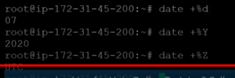

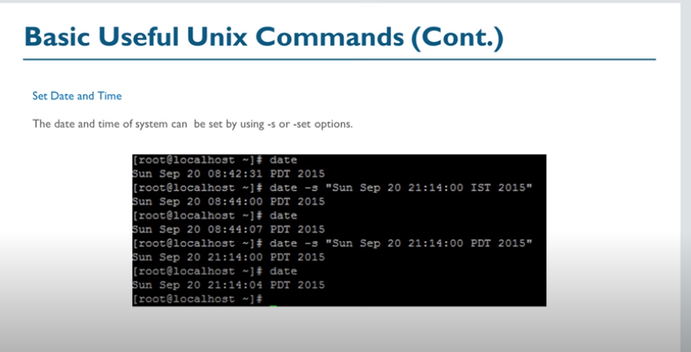

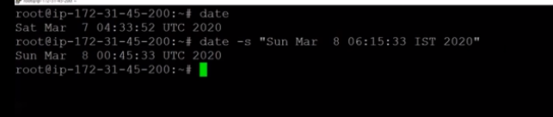

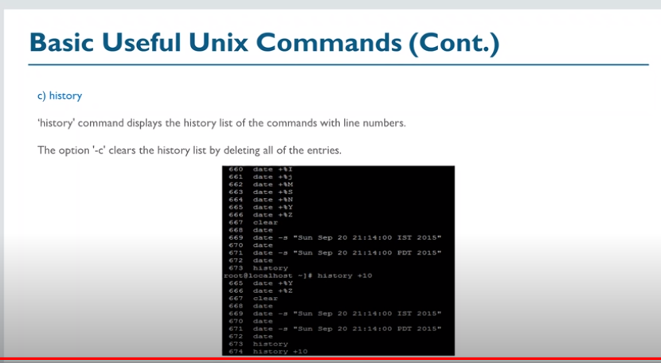

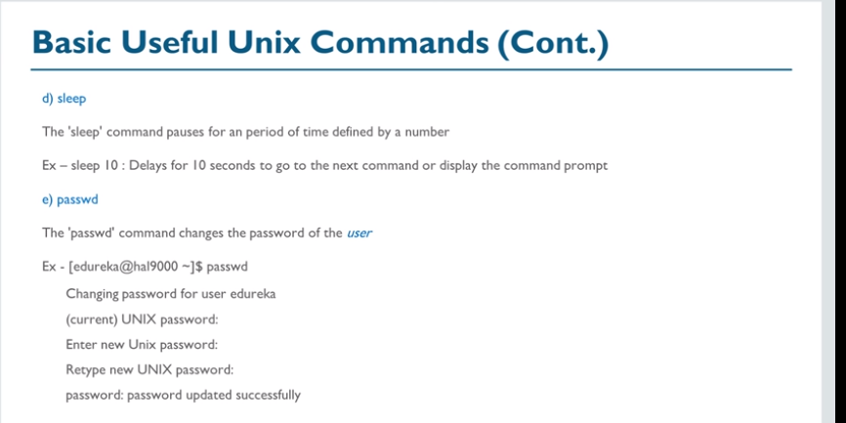

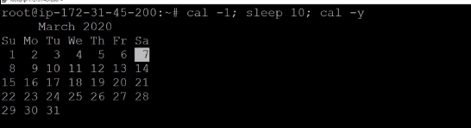

After 10 secconds sleep,

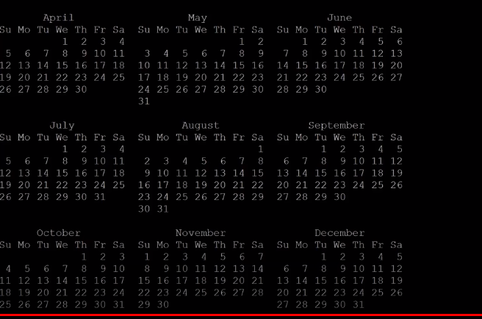

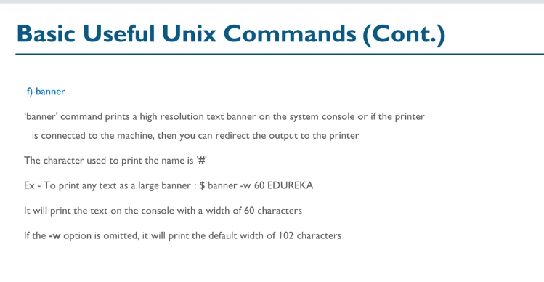

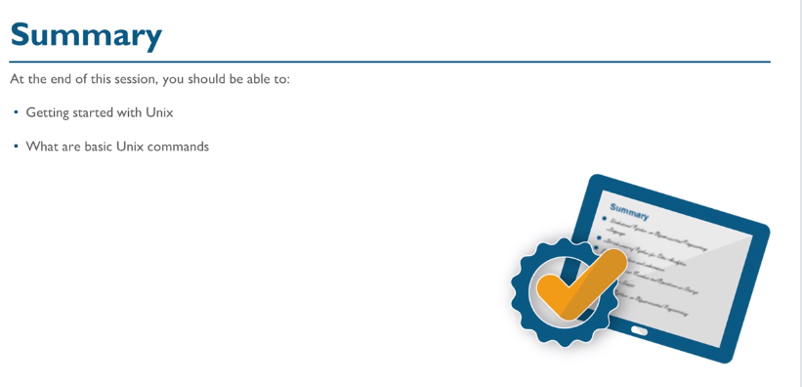



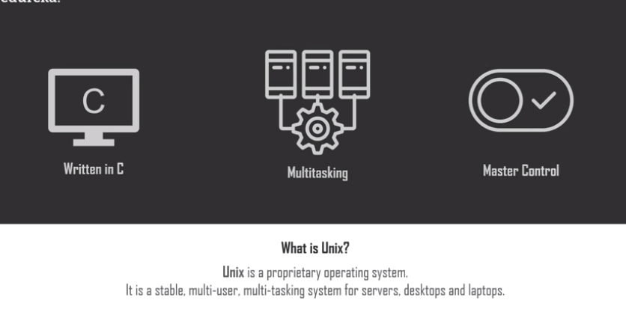

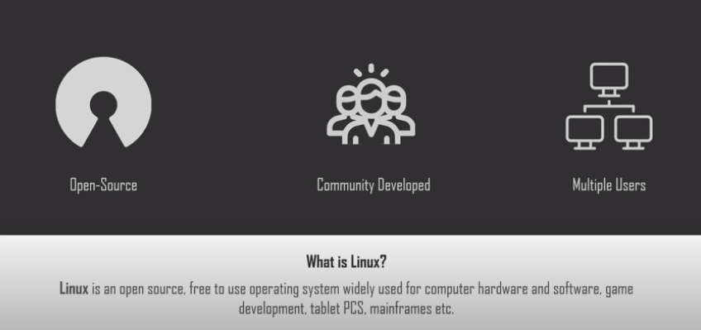

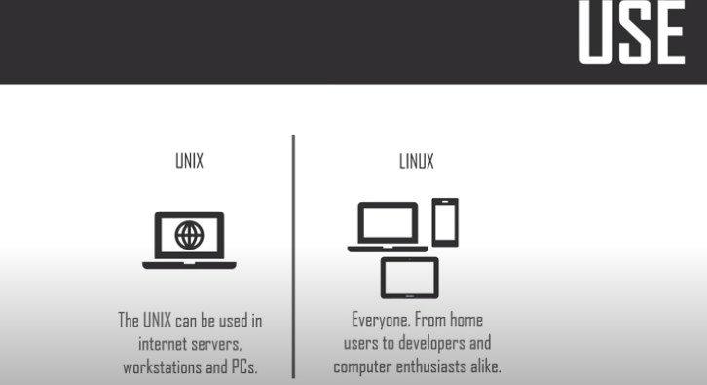

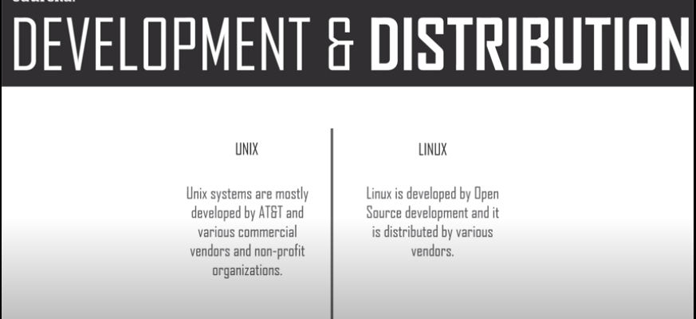



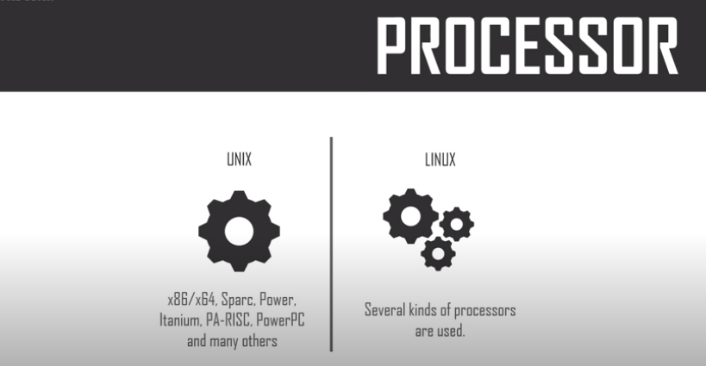

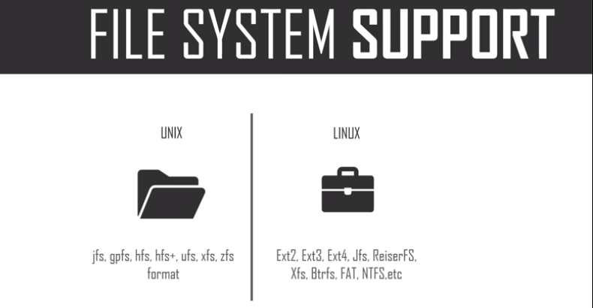

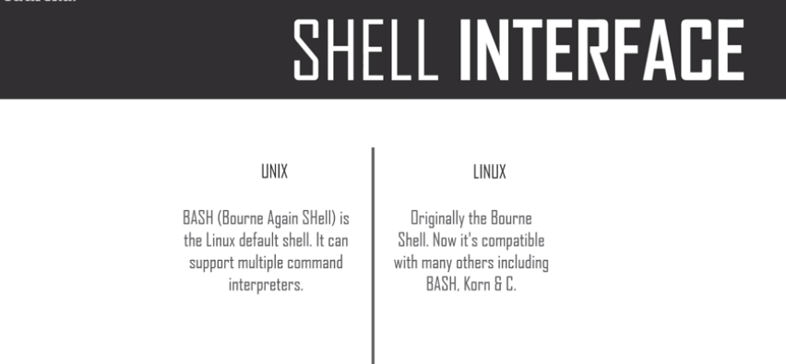

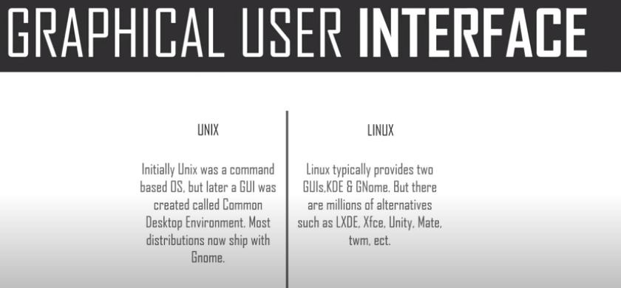

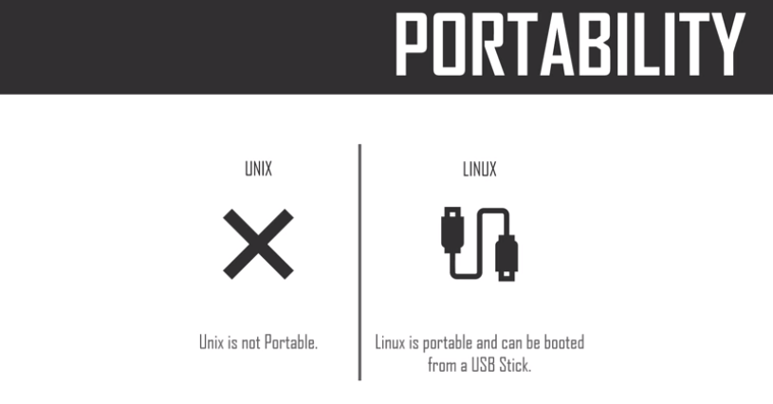

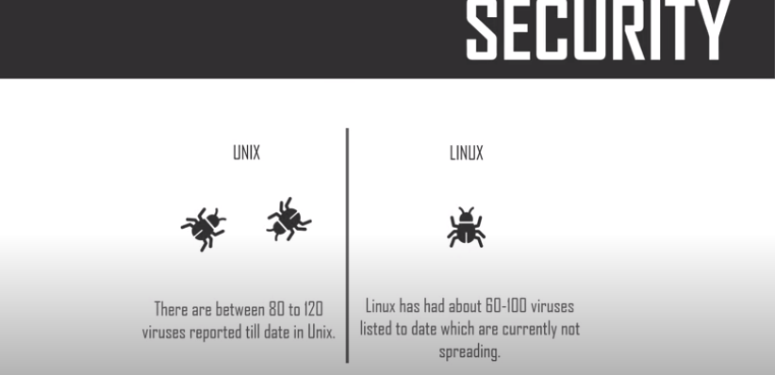

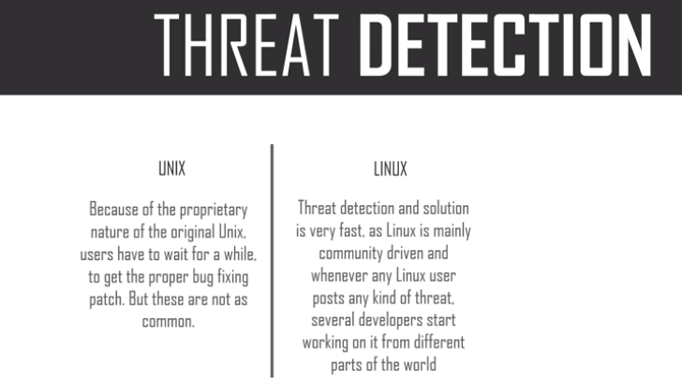

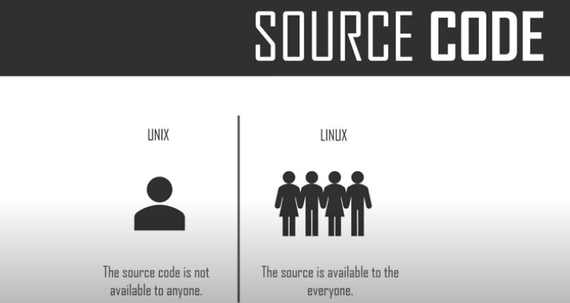



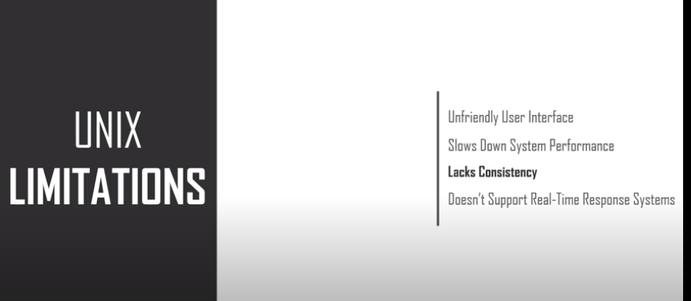







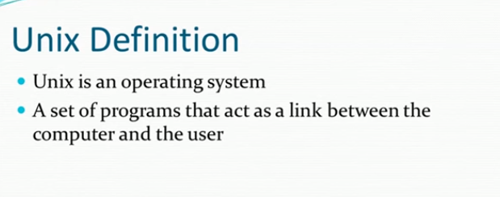

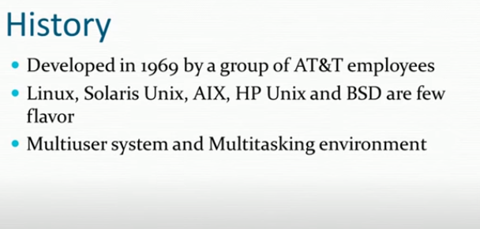

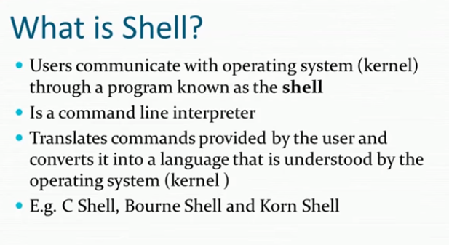

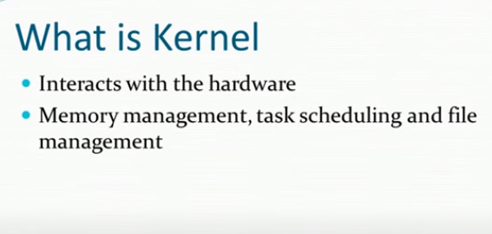

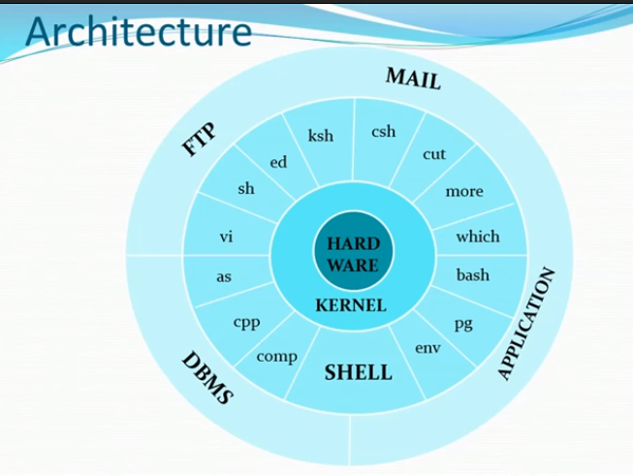

**Today(03/09/2020):**

**Unix:**

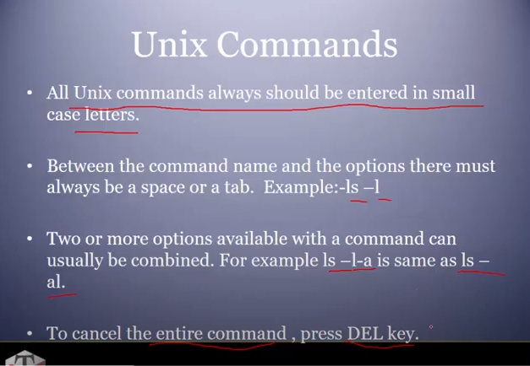

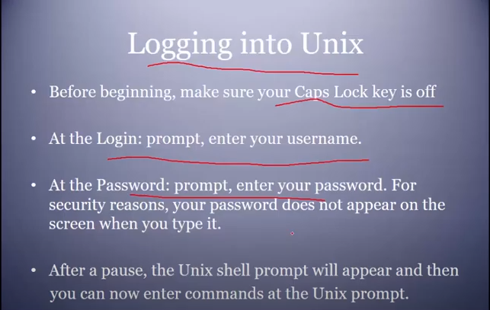

**Cal command:**

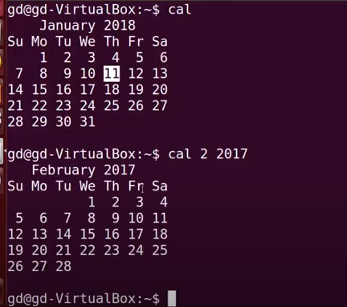

Date command:

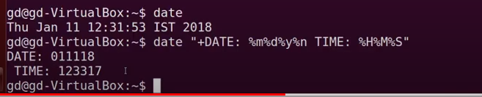

Who command:

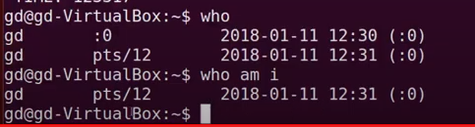

Passwd command:

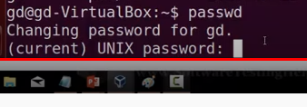

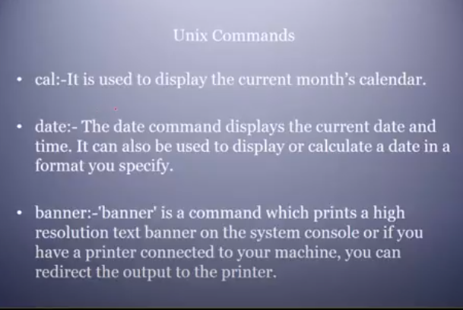

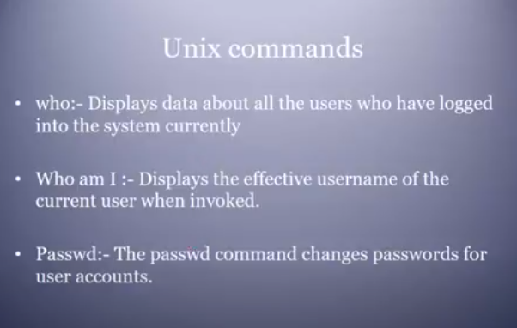

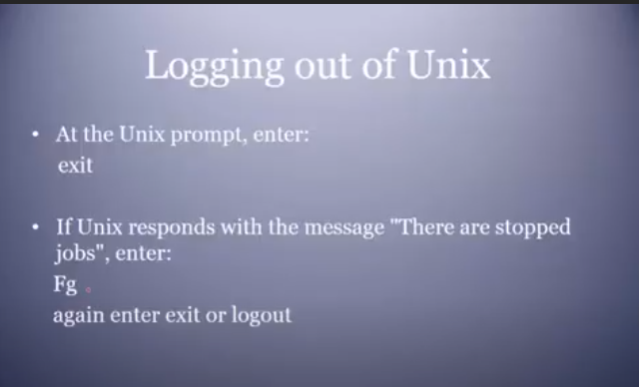

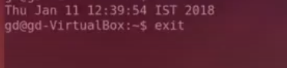

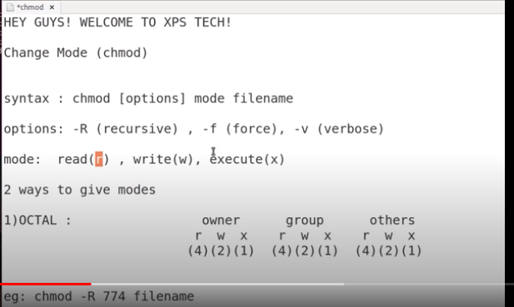

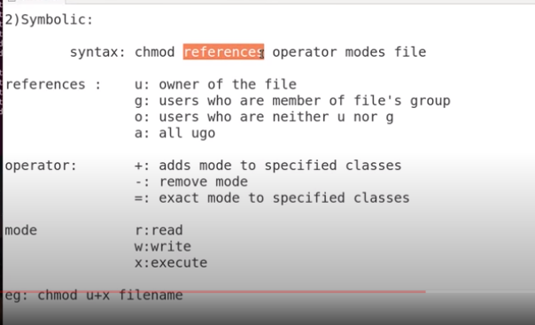

Important: Executed by Ganesh.

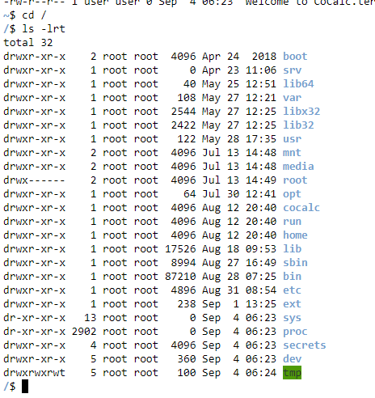

Remove : rm command

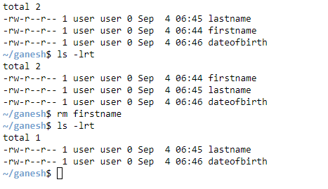

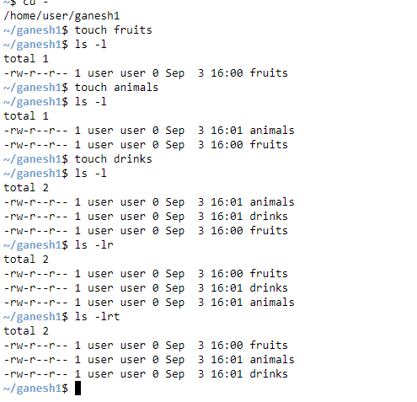

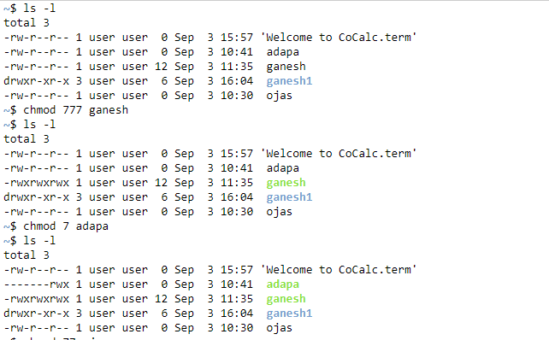

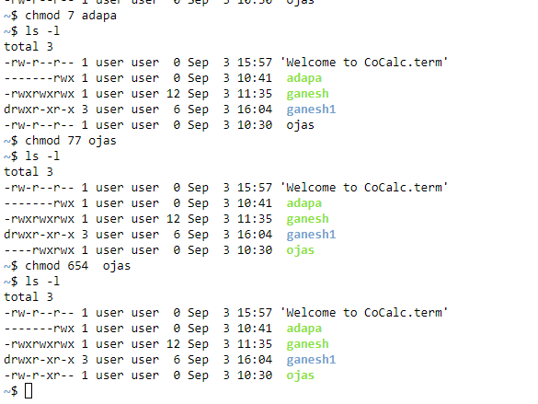

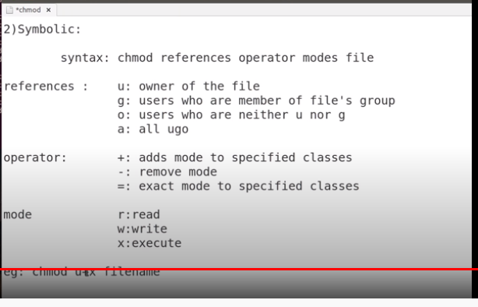

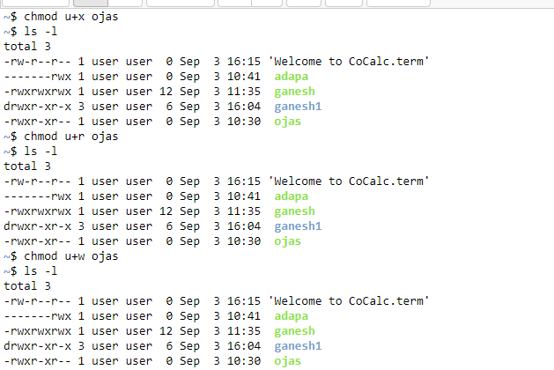

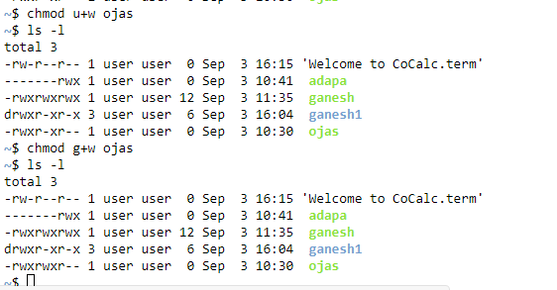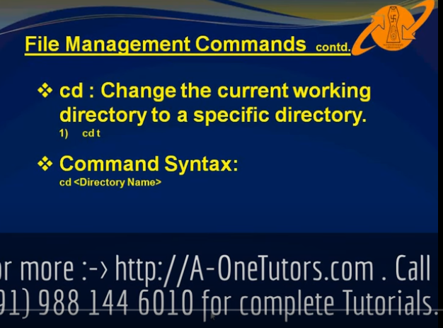

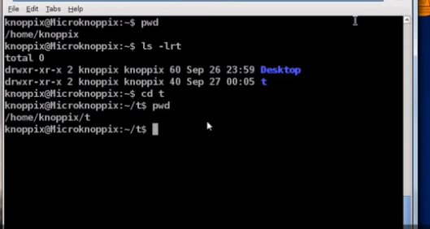

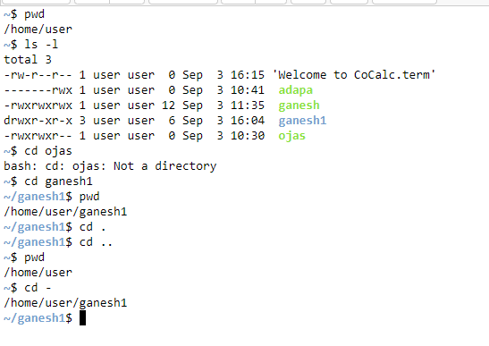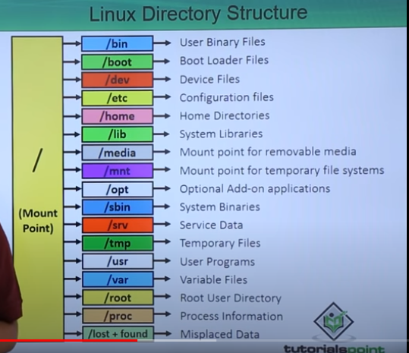

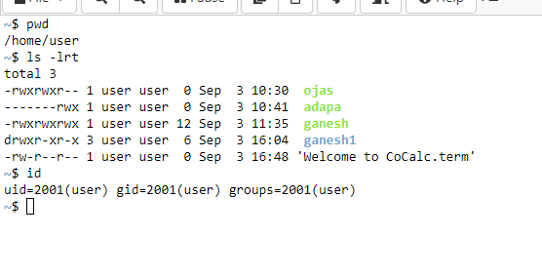

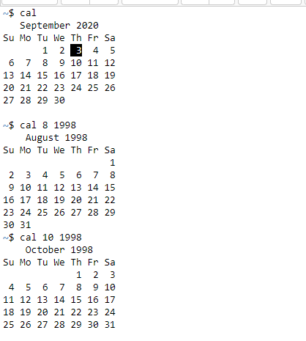

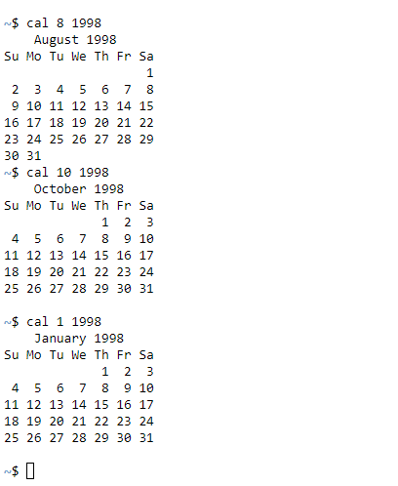

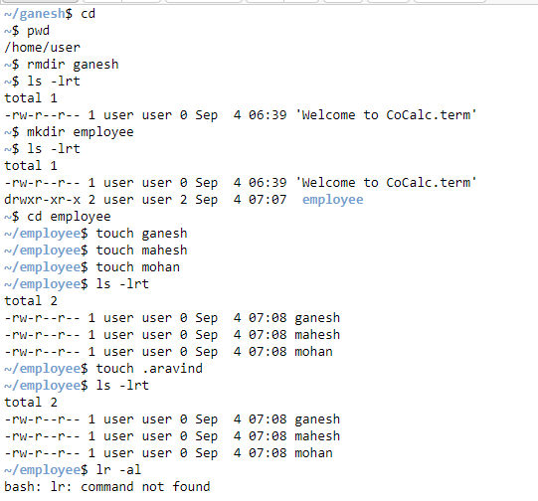

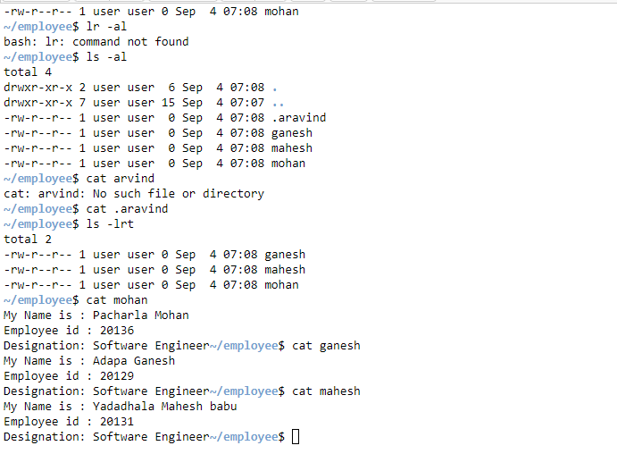

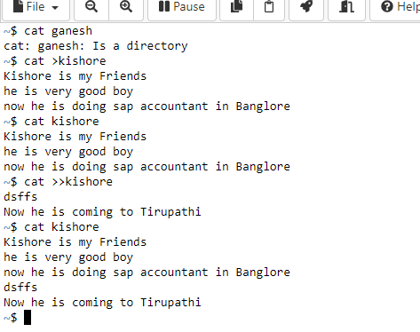

**Today(04/09/2020):**

**Umask:**

The **umask** (**UNIX** shorthand for "user file-creation mode mask") is a four-digit octal number that **UNIX** uses to determine the file permission for newly created files. Every process has its own **umask**, inherited from its parent process.

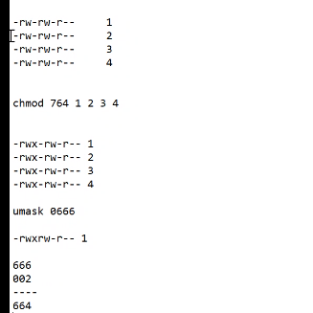

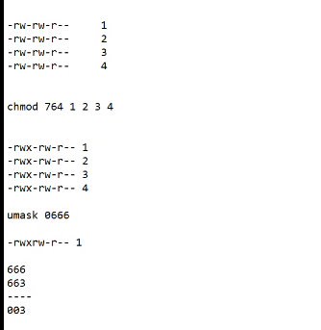

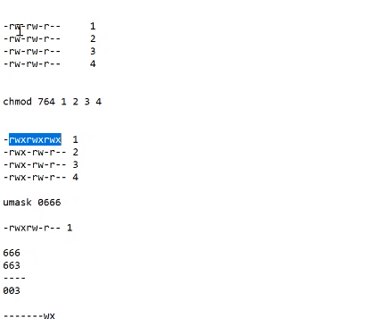

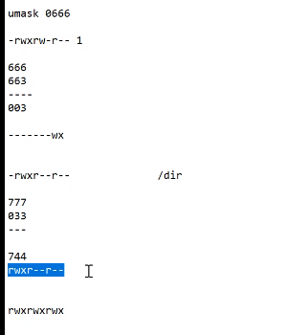

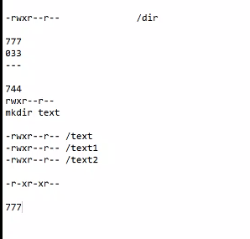

Finally

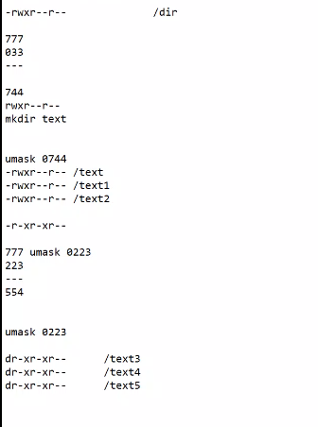

Umask:

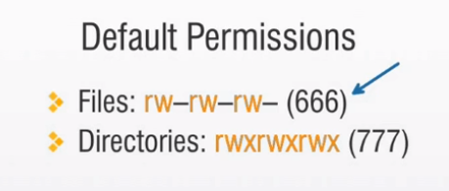

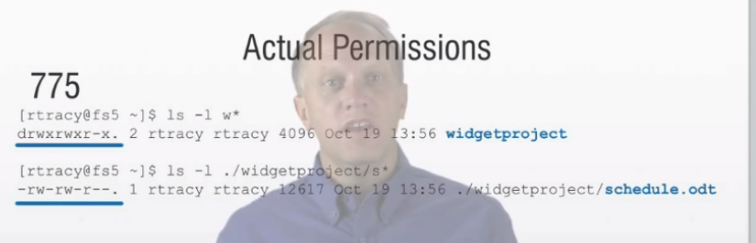

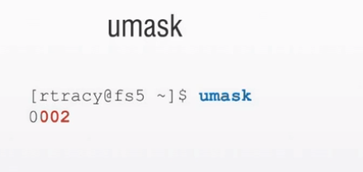

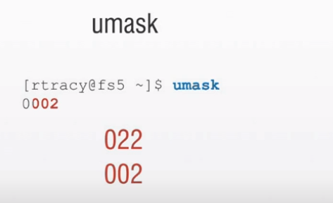

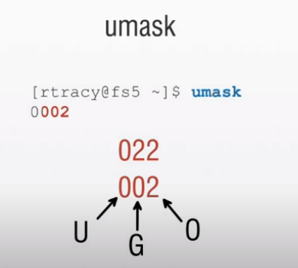

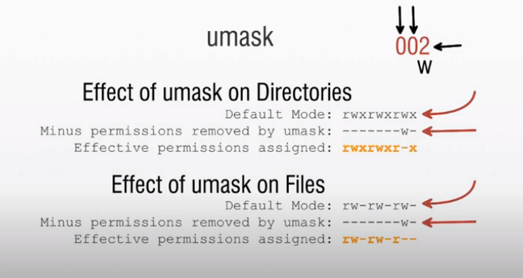

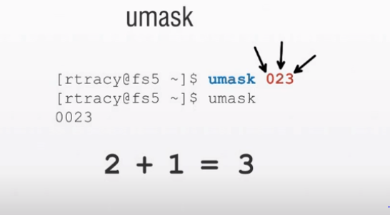

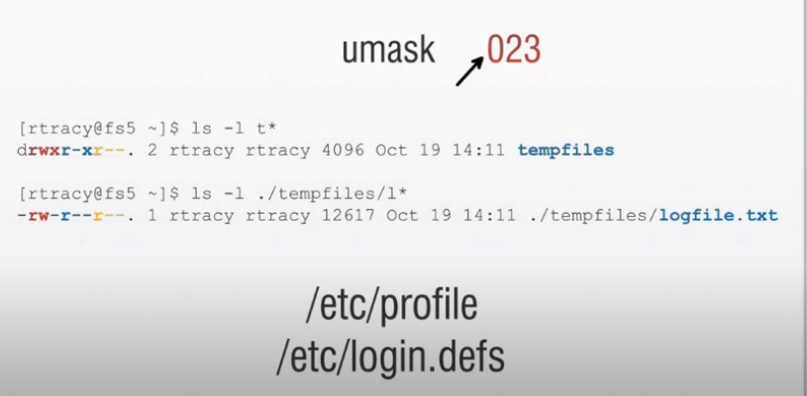

Login Process In Unix:

## The Login Process

The following step-by-step description shows what happens each time a user logs in to a UNIX computer system.

1. Users enters their username.
2. User enters their password.
3. The operating system confirms your name and password.
4. A "shell" is created for you based on your entry in the "/etc/passwd" file (in small businesses, this is usually a Bourne Shell).
5. You are "placed" in your "home"directory.
6. Startup information is read from the file named "/etc/profile". This file is known as the system login file. When every user logs in, they read the information in this file.
7. Additional information is read from the file named ".profile" that is located in your "home" directory. This file is known as your personal login file. (This is the file that usually contains the "menu" program.)

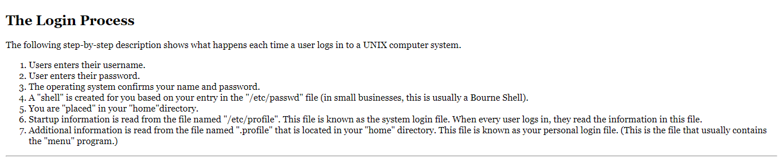

# Exercise: Examining the "login" files.

|  |  |  |
| --- | --- | --- |
| Step | You Type ... | Comments/Prompts |
| 1 | more /etc/profile | This will display the first system startup file that is read when you log in.With the "more" command, you can use the <spacebar> to view the next page, the <Enter> key to view one more line, or type "q" to quit. |
| 2 | more .profile | This will display your personal startup file. |
| 3 | more /etc/passwd | This will display the systems "password" file. |
| 4 | grep 'root' /etc/passwd | "grep" can be thought of as search. It lets you search for text within files. This command searches for the text string "root" within the file named "/etc/passwd". |

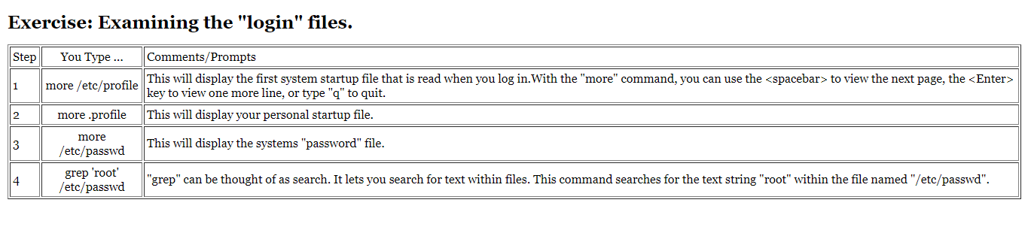

**Today(05/09/2020):**

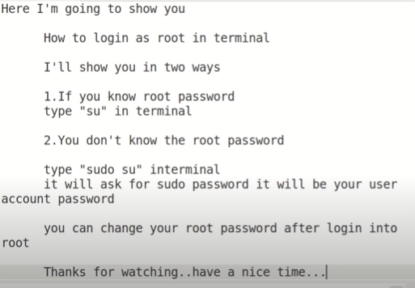

Mv command:

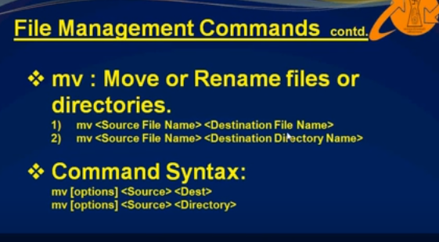

Rename Execution:

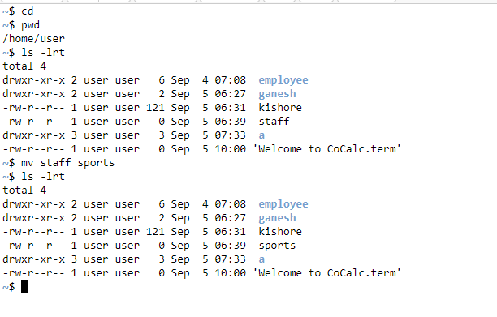

**Moving files to a directory :**

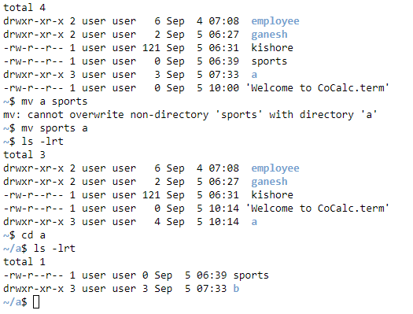

Copy Command in Unix as cp:

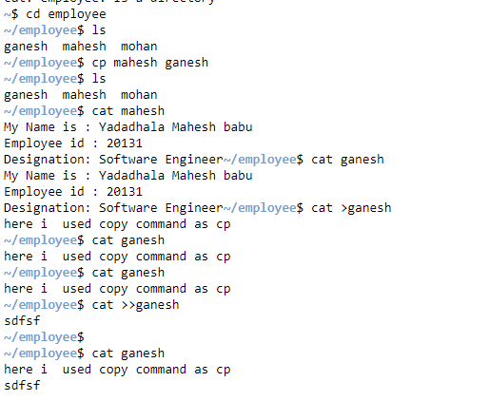

L**ogin Process in Unix:**

**Process :**

A ****process**** refers to a program in execution; it’s a running instance of a program. It is made up of the program instruction, data read from files, other programs or input from a system user.

#### **The Init Process**

****Init**** process is the mother (parent) of all processes on the system, it’s the first program that is executed when the [Linux system boots up](https://www.tecmint.com/linux-boot-process/" \t "https://www.tecmint.com/linux-process-management/_blank); it manages all other processes on the system. It is started by the kernel itself, so in principle it does not have a parent process.

The init process always has process ID of ****1****. It functions as an adoptive parent for all orphaned processes.

You can use the ****pidof command**** to find the ID of a process:

# pidof systemd

# pidof top

# pidof httpd

**[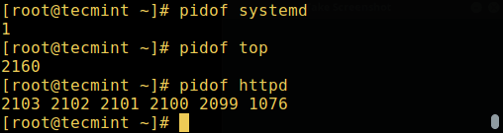](https://www.tecmint.com/wp-content/uploads/2017/03/Find-Linux-Process-ID.png)**

Actual Process:

/etc: **almost all system-wide configuration files are under /**etc**, but not all files in /**etc** are configuration files**

<https://www.linuxnix.com/how-login-process-work-in-linux/>

**Today(07/09/2020):**

**Searching commands in unix:**

1. **Find**
2. **Grep**
3. **Find**

**Find:**

The find command in UNIX is a command line utility for walking a file hierarchy. It can be used to find files and directories and perform subsequent operations on them. It supports searching by file, folder, name, creation date, modification date, owner and permissions.

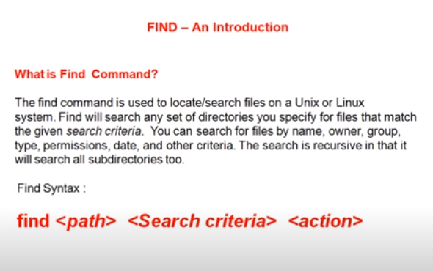

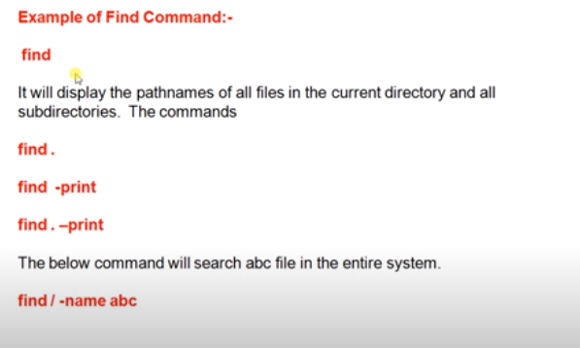

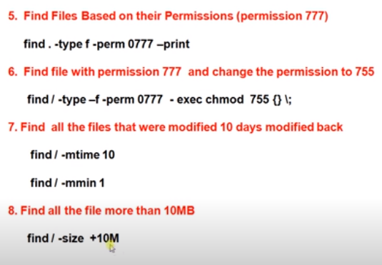

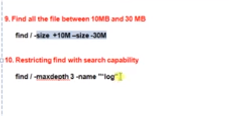

**grep Command**

**grep:**

The **grep command** is used to search text. It searches the given file for lines containing a match to the given strings or words. It is one of the most useful commands on Linux and Unix-like system.

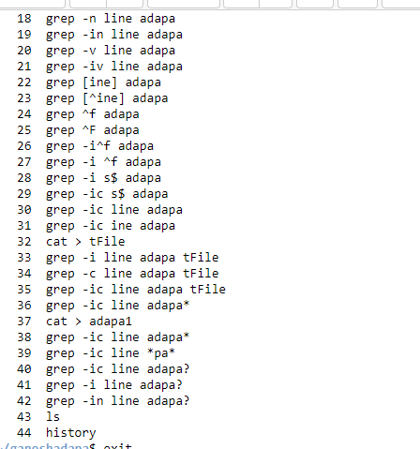

Execution:

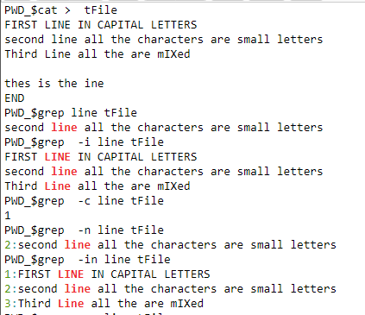

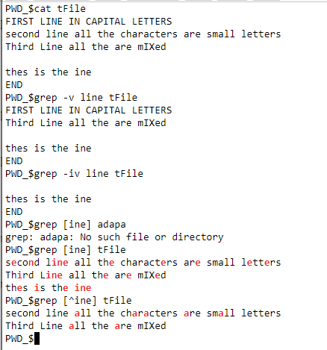

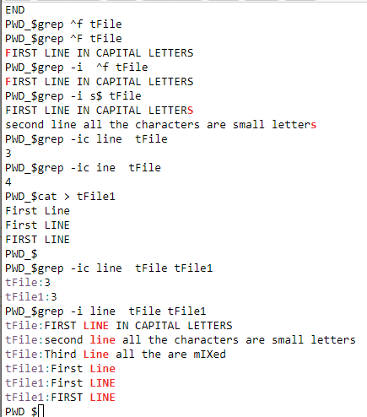

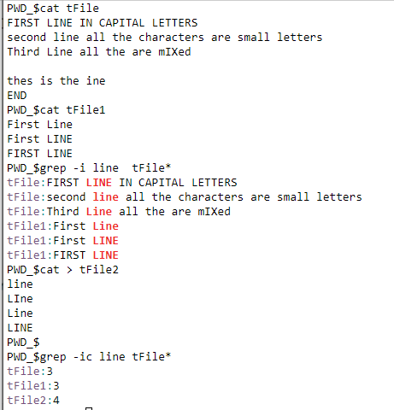

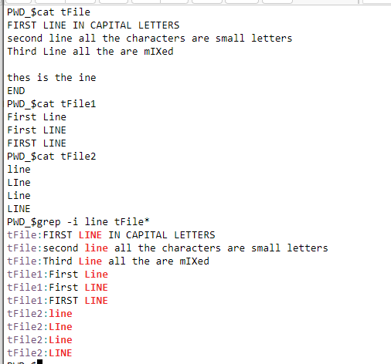

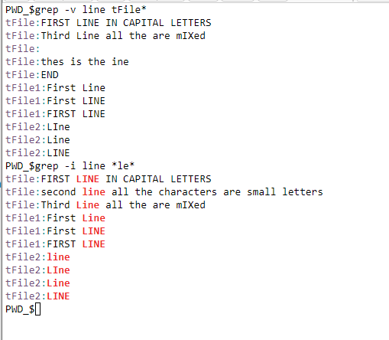

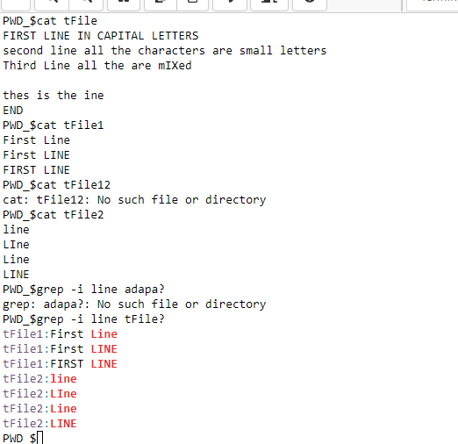

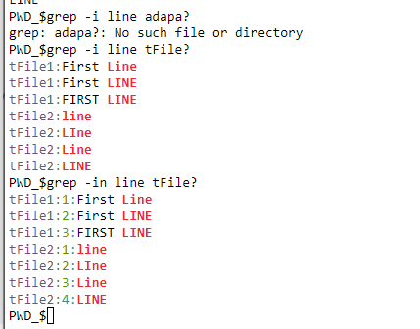

? : is only for two letters staring filename refers,

So,

Here

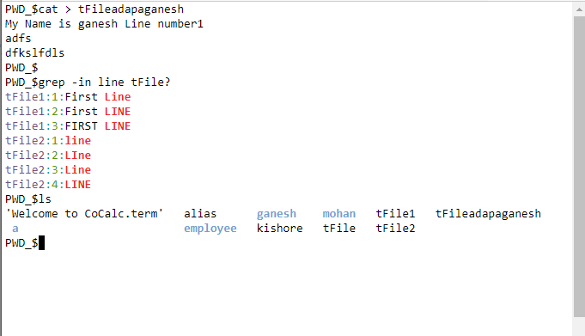

The main **difference between** the two **is** that **grep is** used to search for a particular string **in a** file whereas **find is** used to locate files **in a** directory, etc

**Important for Find:**

<https://www.tecmint.com/35-practical-examples-of-linux-find-command/amp/>

There are different ways for diff types of files for searching :

1. Locate command:

locate filename.

so that filename related all files path we will get.

it is quicker because it maintains its own database.

so if we create new files then to get its path we need to

write one command that is 'updatedb' which will update that

database and then we can search by locate command.

we can also find hidden files suppose we wanted to find .bashrc

then simply we can write 'locate .bashrc'.

but it does not provide any options for findind the file

permissions.

we can also find particular files like text files suppose we want to find

then we can use 'locate /etc *.txt' where we can get all files whose

extension is txt.

So we can say for quiker finnding of files we can use locate command

but there is one drawback of locate i.e sometimes the database might

not be updated so in that case we might get wrong outcome.

there is another command which is FIND

2. Find Command :

Find command is used to search and locate the list of files and directories based on conditions

we specify for files . Find can be used in different conditions like for searching

files by permissions, users, groups, file type, size, and other criterias.

i. we can find file by name :

we need to use command as

'find /root -name suyash'

'find / -name suyash'

* and if want from current directory then we can simply use:

'find . -name suyash'

ii. for finding using file type :

'find /root -type f -name "suyash*" '

so here we can find all files with filename containing suyash and f here is for file.

and for directories

'find /root -type d -name "suyash*" '

so here we can find all directories with name containing suyash and d here is for directory.

but here what happened is that it will search but case will be insensitive.

so for ignoring the cases:

'find /root -iname suyash '

here i stands for ignore case so if there is mismatch by user then also it will find the files.

in some cases we need to find files except some specific files then there we can use :

'find /root -not -name suyash '

alternatively we can use exclaimation mark also instead of -not.

it will find all files except the name suyash.

for finding hidden files we can use : 'find /root -name ".*" '

iii. for finding for file permissions :

suppose we want to find files which has 777 permissions that is all permission for all the users then

we can use :

'find /root -type f -perm 777 '

likewise we can search for different permissions also.

iv. for searching in multiple directories :

like if we want to search one filename in different directories we can use :

'find /root /var /etc -name yash '

v. for searching a file with read only permission:

' find /root -maxdepth 1 -perm /u=r '

by using this we'll get read only files.

Max depth is used for maximum depth.

we can mention To find “file1” only in the “level1” directories and above, can specify a max depth of

2 (1 for the top-level directory, and 1 for the level1 directories).

vi. for searching files with execute permissions :

' find /root -maxdepth 1 -perm /a=x '

vii. for searching files based on modified time :

' find /root -mtime 10 '

here we will get all files which are modified in last 10 days and mtime is for modified time.

viii. for searching files accessed :

' find /root -atime 10 '

here we will get all files which are accessed in last 10 days and atime is for access time.

iX. we can also limit the time by using :

' find /root -mtime +10 -mtime -20 '

here we will get all files which are modified in last 10 to 20 days and +10 means more than

10 days and -20 means less than 20 days.

X. for searching files accessed in last 60 minutes :

' find /root -cmin -60 '

here we will get all files which are accessed in last 60 minutes.

Xi.X. for searching files modified in last 60 minutes :

' find /root -mmin -60 '

here we will get all files which are modified in last 60 minutes.

Xii.X. for searching files modified in last 60 minutes :

' find /root -amin -60 '

here we will get all files which are accessed in last 60 minutes.

xiii. searching files based on size :

' find / -size 10M '

xiv. searching empty files:

' find /root -type f empty '

xv. searching files based on group permission :

' find /root -group admin '

[touch file{1....10}.txt]

xvi. we can also search the file and as soon as we get that file we can delete it:

by using search command

find /root -type f -name "*.txt" -exec rm -f {} \;

**Today(08/09/2020):**

**Vi Editor:**

A **text editor :** is a program used for editing text files. Most configuration of Linux systems is done by editing text files. All Linux distributions ship with multiple text editors included.

There are two types of text editors in Linux:

* ****commandline editors**** – vi, nano, pico
* ****GUI editors**** – gedit (for GNOME), KWrite (for KDE)



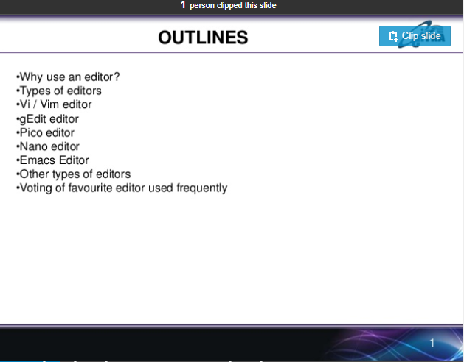

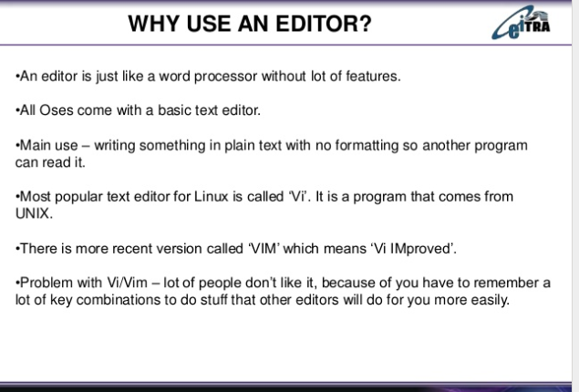

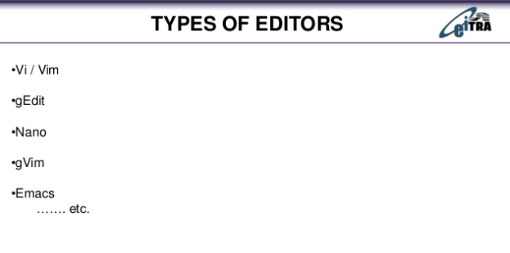

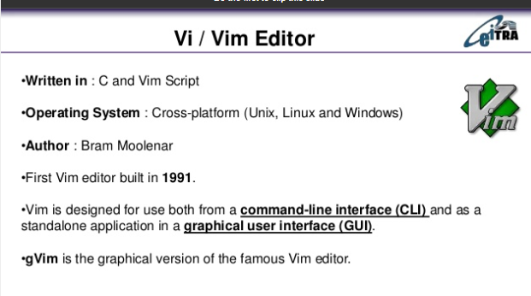

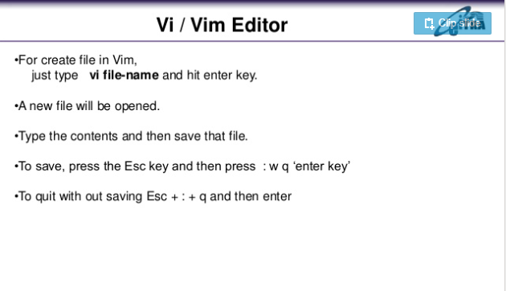

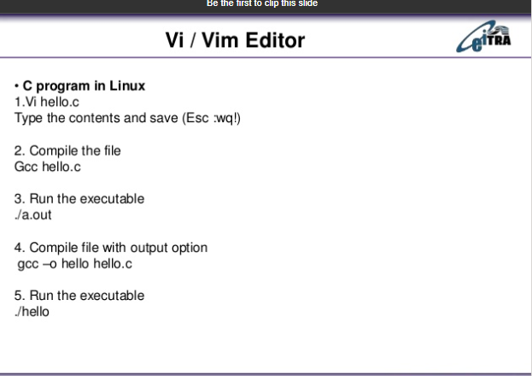

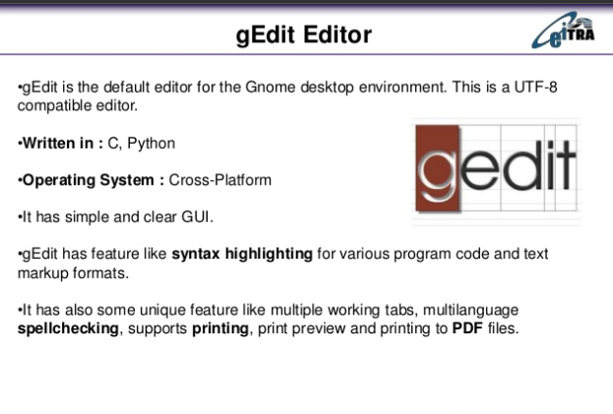



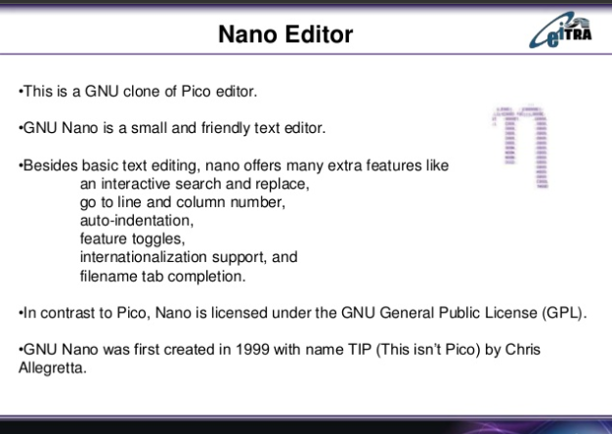

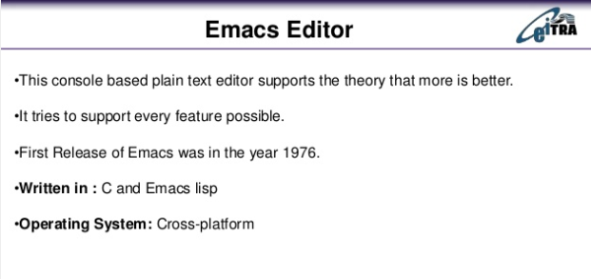

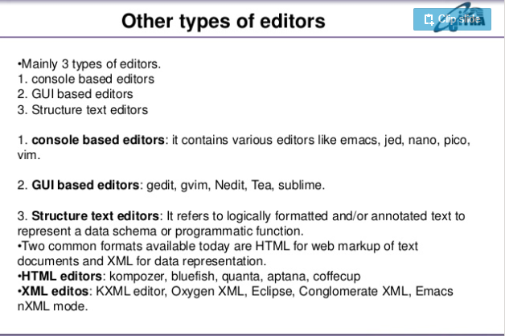

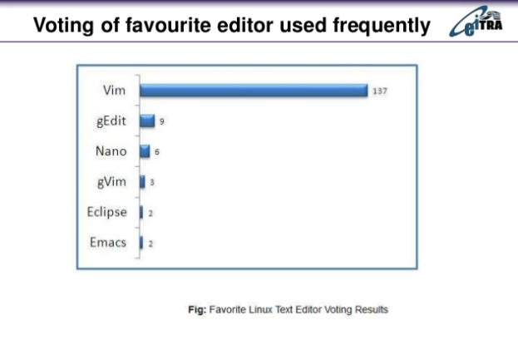

**Important:**





A **text editor :** is a program used for editing text files. Most configuration of Linux systems is done by editing text files. All Linux distributions ship with multiple text editors included.

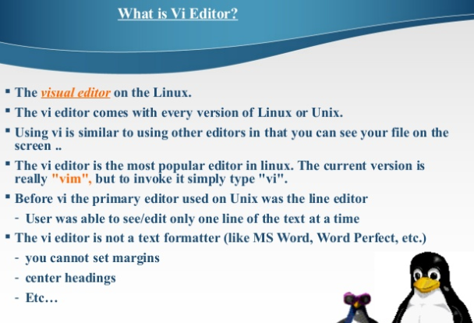

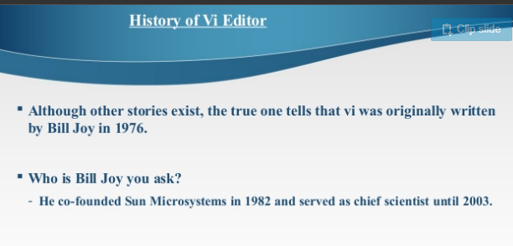

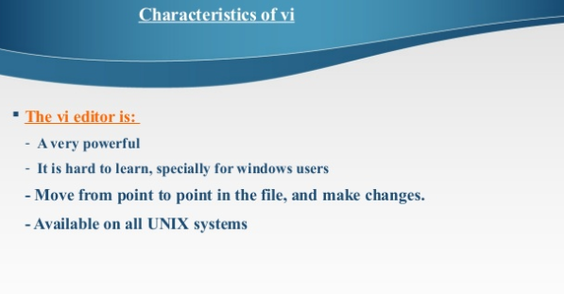

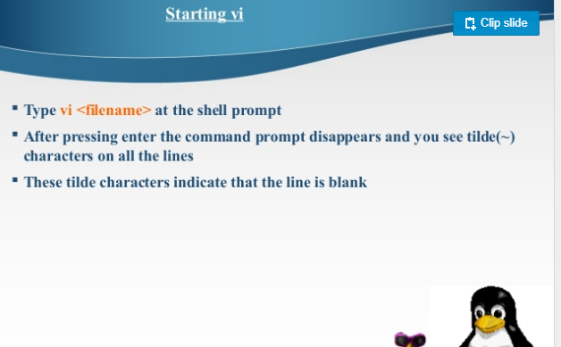

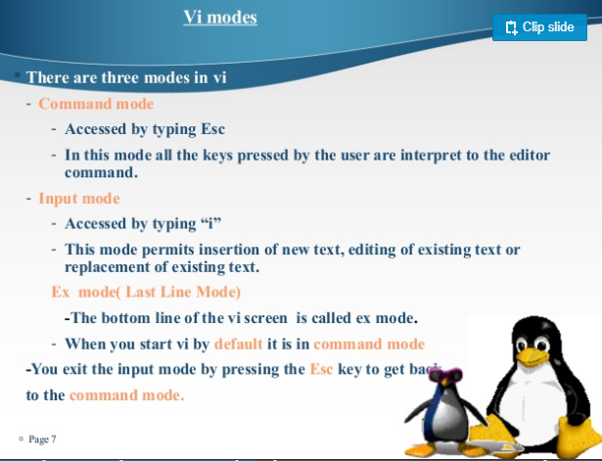

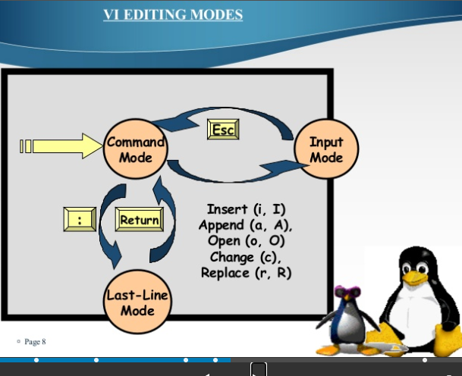

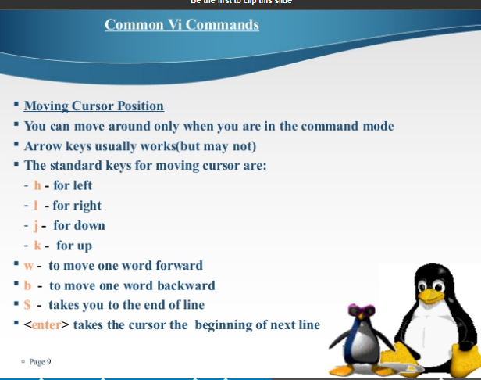H

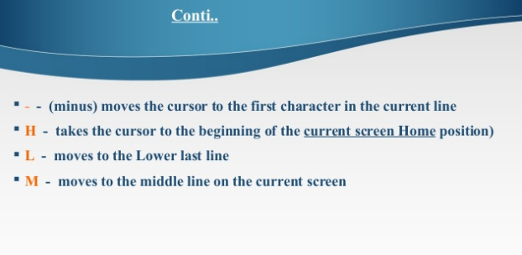

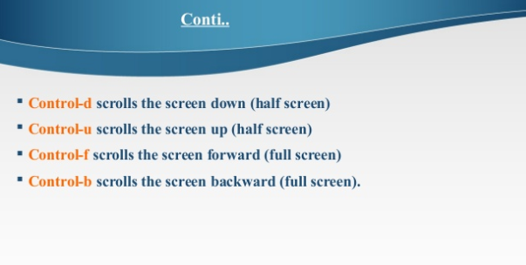

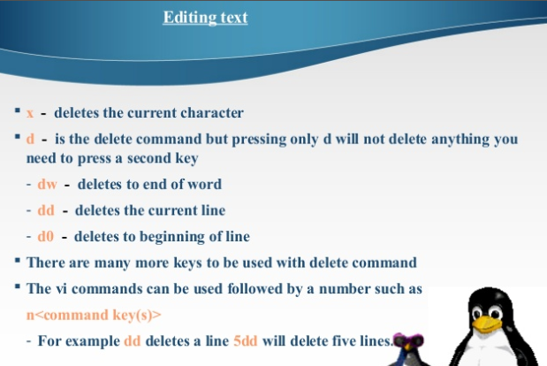

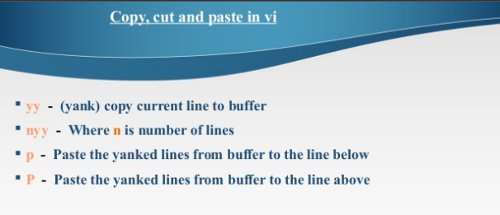

A **buffer :**, also called **buffer** memory, is a portion of a computer's memory that is set aside as a temporary holding place for data that is being sent to or received from an external device, such as a hard disk drive (HDD), keyboard or printer. ... Most text editors store the file being written or edited in a **buffer**.

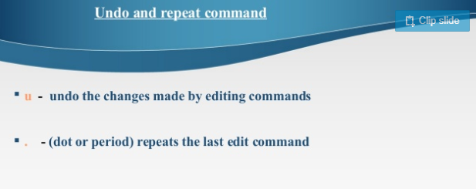

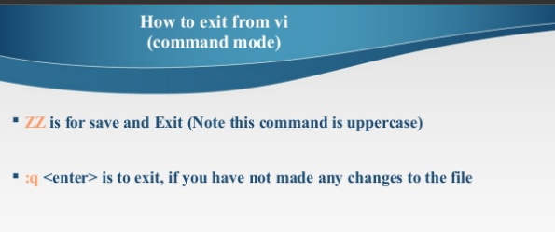

**Today(10/09/2020):**

**Shell Scripting in Unix:**

**Shell:** Shell in terms of UNIX basically means user interface. It means that a shell is either a command line interface (CLI) or a graphical user interface (GUI).

**Shell script:** A **shell script** is a computer program designed to be run by the **Unix shell**, a command-line interpreter

**Types of scripts:**

The types of shell available for Linux:

1. Sh
2. Bash
3. Tsh or tcsh
4. ksh

**sh**

The original shell developed for Unix at the AT&T's Bell Labs

American Telephone & Telegraph Company

**bash**

The shell got popular and soon developers made their own version of a shell with some tweaks which is known as bash or "Bourne-again Shell," has become the new default standard.

**csh and tcsh**

Developers had written a large part of Linux OS in C and C++ languages. Using c syntax they developed csh at Berkley University. Ken Greer took concepts of csh and took it a bit forward and developed a new shell named as tcsh.

**ksh**

**David**Korn developed the Korn shell, or ksh, about the time tcsh while Ksh was compatible with sh and bash and improved the bourne shell.

**How to invoke:**

**2 Invoking Shell Scripts**

There are two ways to invoke a shell script file.

* 1. **Direct Interpretation :** In direct interpretation,

command :csh filename [arg ...]

invokes the program csh to interpret the script contained in the file ‘filename’.

* 1. **Indirect Interpretation**

In indirect interpretation,

we must insert as the first line of the file

#! /bin/csh

Or

#! /bin/csh -f

and the file must be made executable using chmod . Then it can be invoked in the same way as any other command, i.e., by typing the script file name on the command line

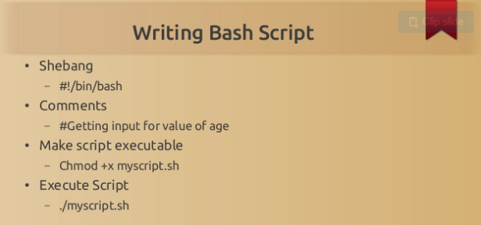

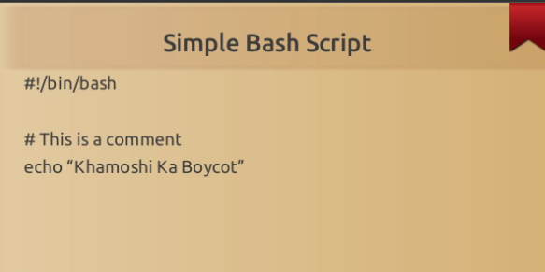

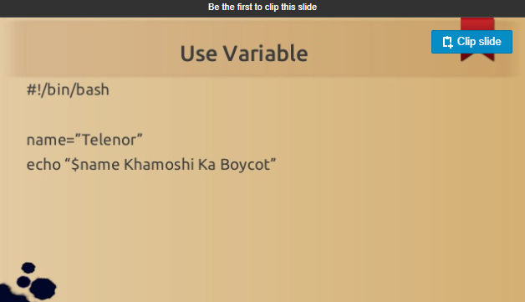

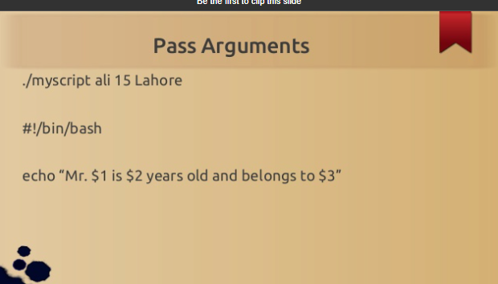

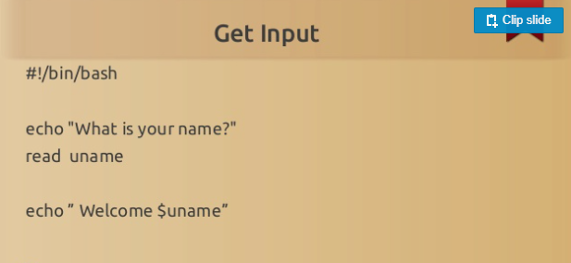

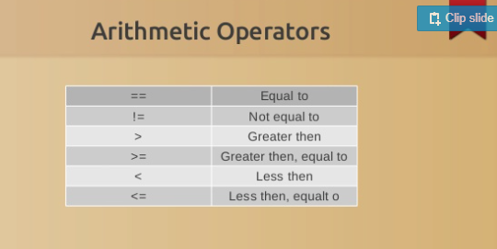

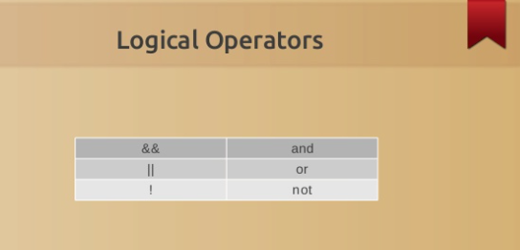

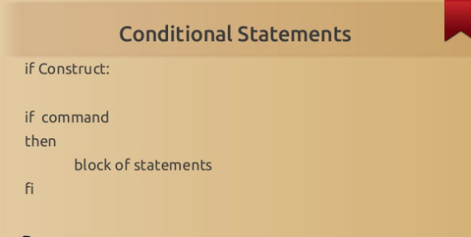

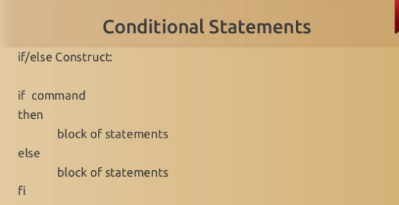

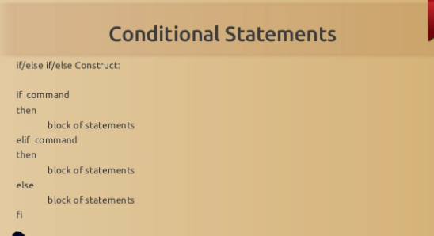

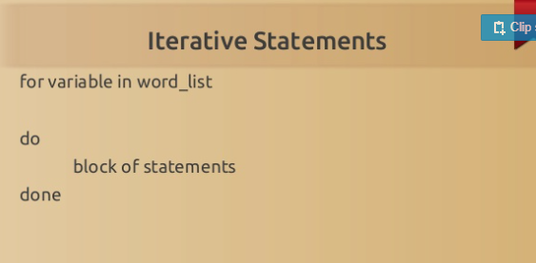

**While:**

Syntax:

while ( expr )

Commandlist

end

**Array’s:**

#! /bin/bash

# To declare static Array

arr=(prakhar ankit 1 rishabh manish abhinav)

# To print all elements of array

echo ${arr[@]}

echo ${arr[*]}

echo ${arr[@]:0}

echo ${arr[*]:0}

# To print first element

echo ${arr[0]}

echo ${arr}

# To print particular element

echo ${arr[3]}

echo ${arr[1]}

# To print elements from a particular index

echo ${arr[@]:0}

echo ${arr[@]:1}

echo ${arr[@]:2}

echo ${arr[0]:1}

# To print elements in range

echo ${arr[@]:1:4}

echo ${arr[@]:2:3}

echo ${arr[0]:1:3}

# Length of Particular element

echo ${#arr[0]}

echo ${#arr}

# Size of an Array

echo ${#arr[@]}

echo ${#arr[*]}

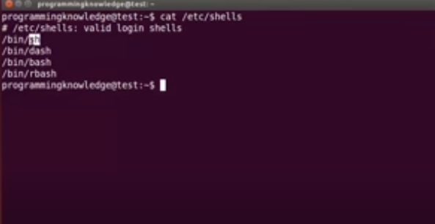

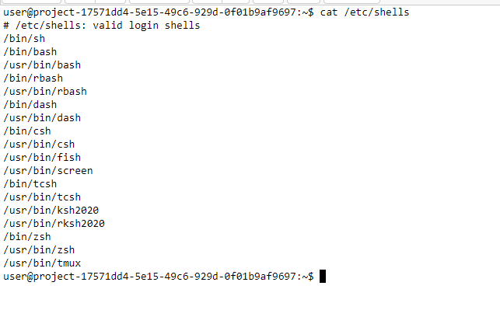

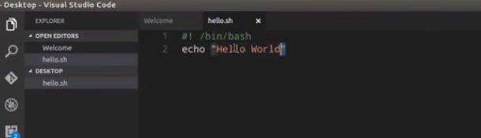

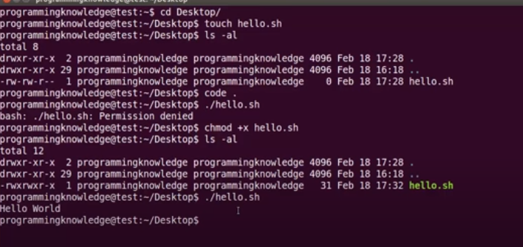

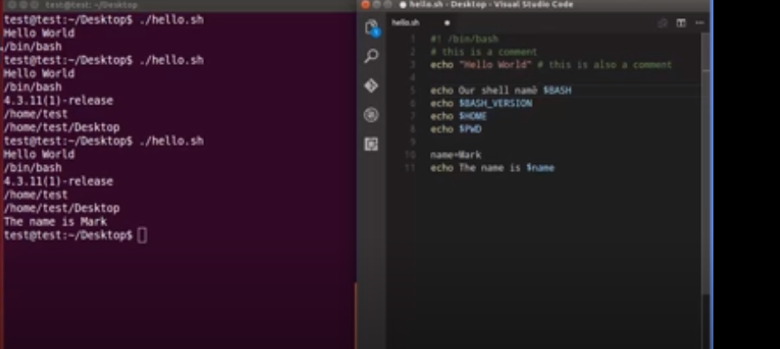

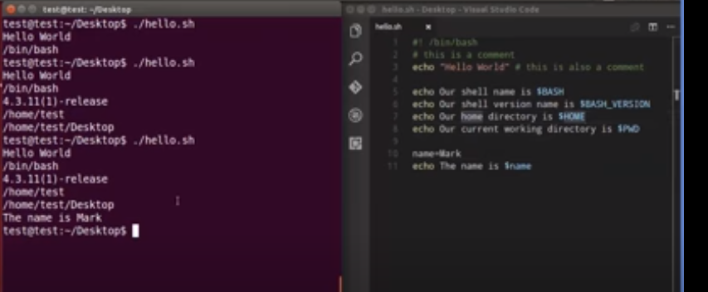

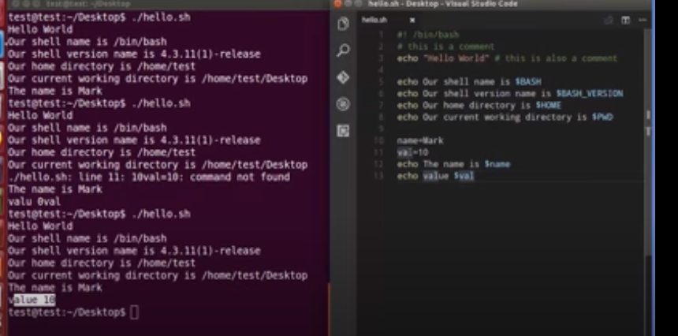

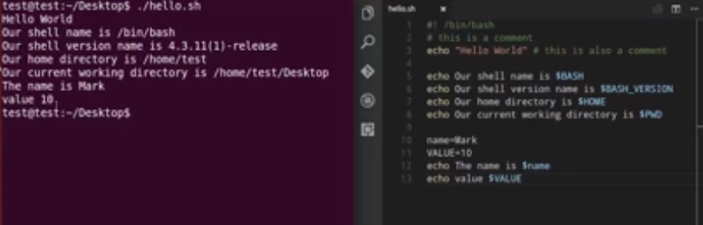

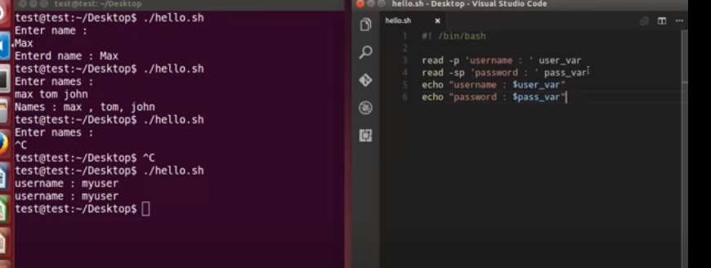

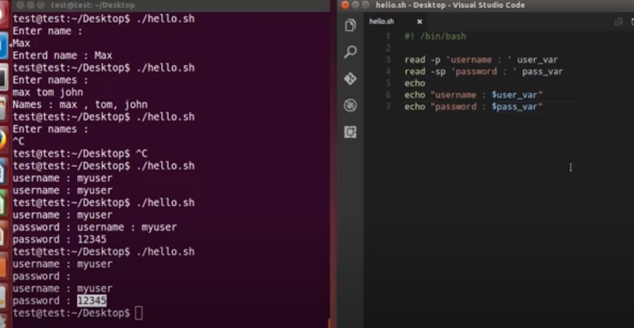

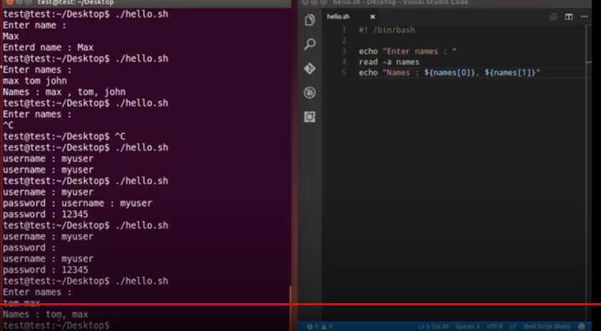

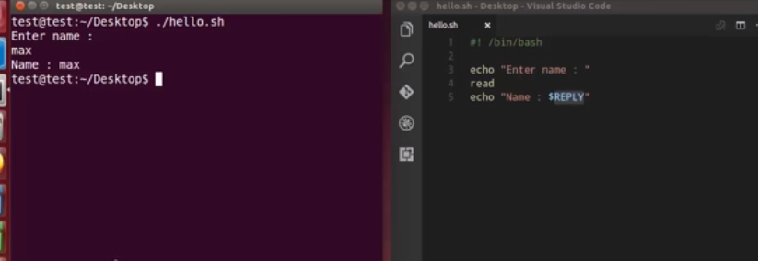

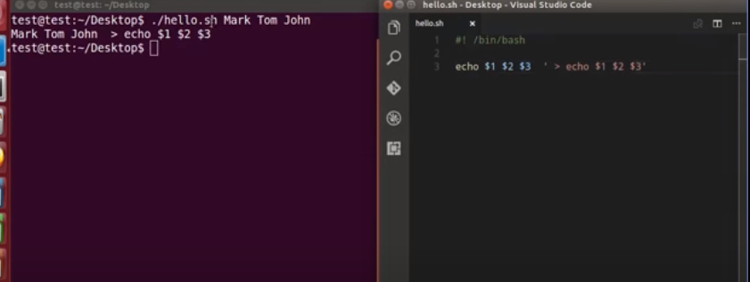

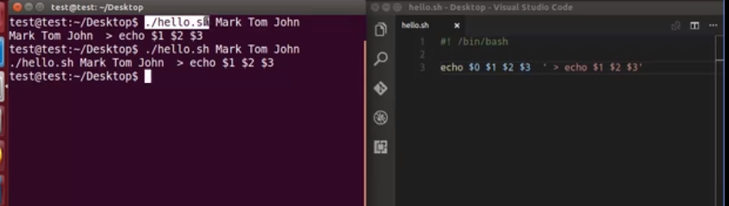

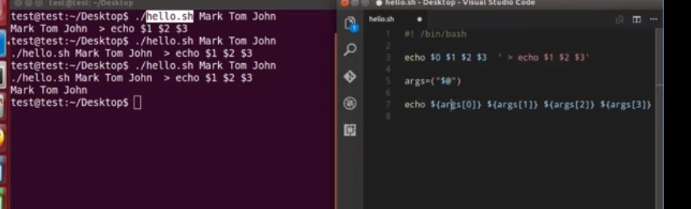

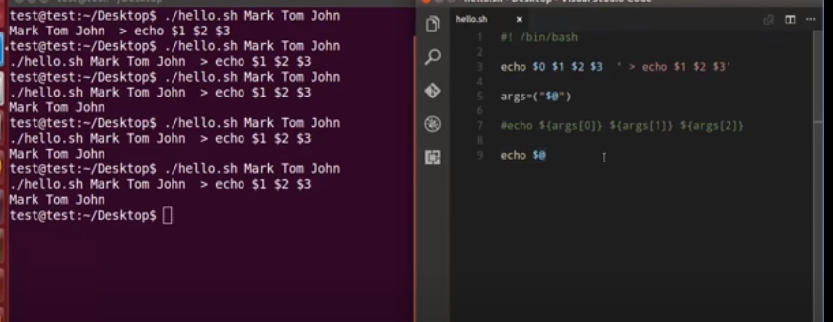

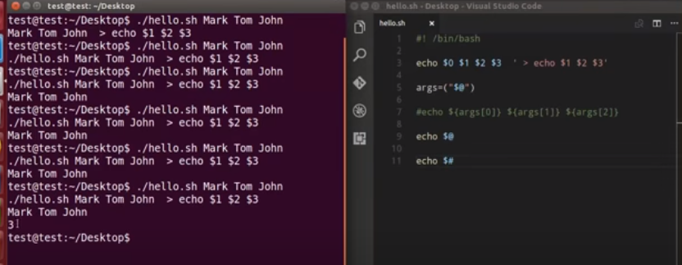

How to add two numbers using shell scripting:

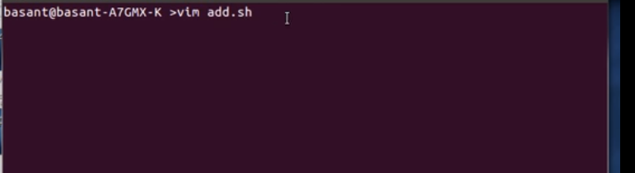

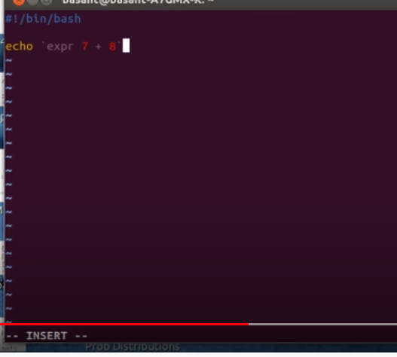

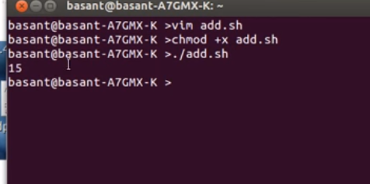

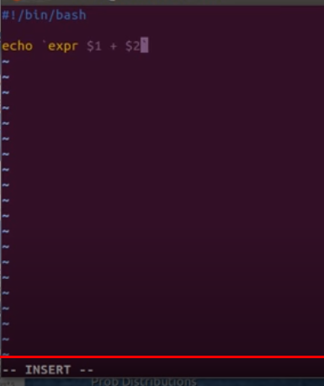

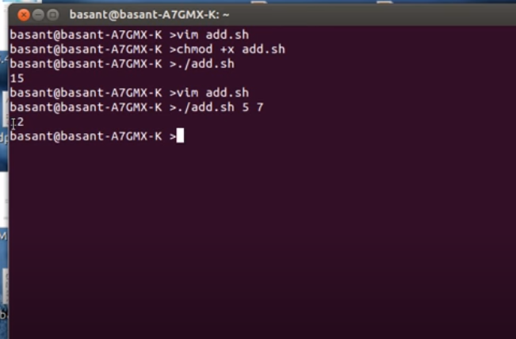

Notes:

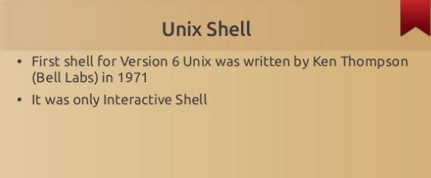

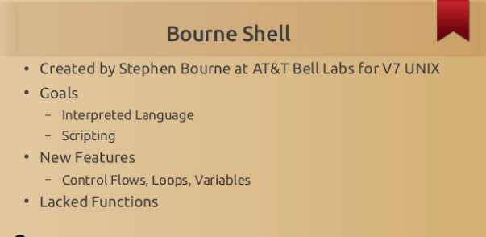

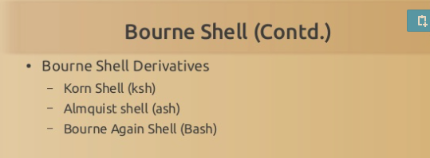

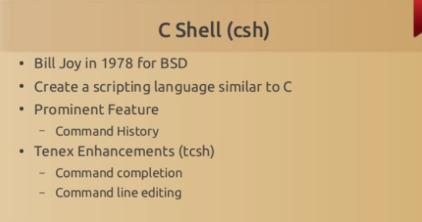

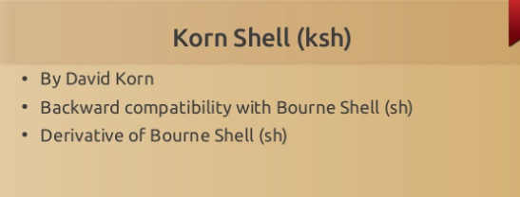

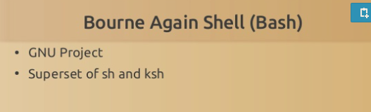

**Execution:**

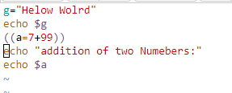

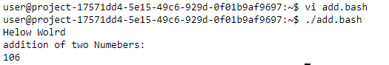

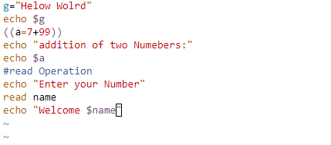

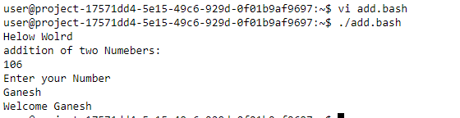

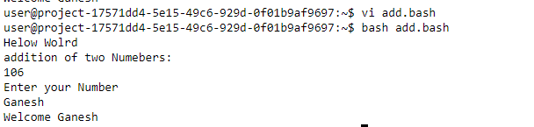

**Today(10/09/2020):**

**Shell script advantage:**

**-> reusability of the code**

**Why we need #!/bin/bash , #!/bin/csh,?**

we need to write because the user can understand what type of shell your are written the code, and what type of extension I need to use he can find easily

1. Hellow world program



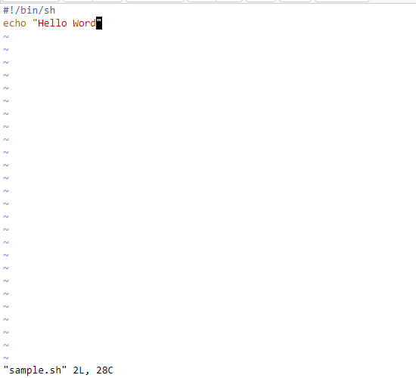

**Output:**

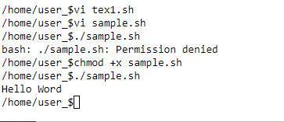

1.($) passing arguments:

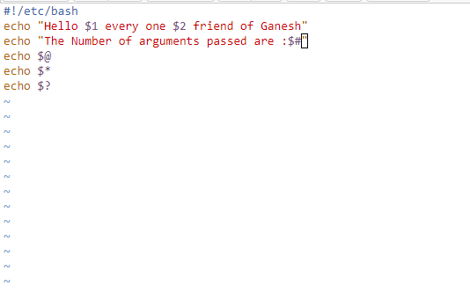

**Output:**

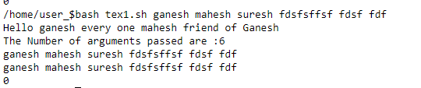

**Here,**

**$- used for passing arguments**

**$# - Number of arguments passed.**

**$*,$@ - used to print the passed arguments**

**$? - tells the process execution information.**

Tody(11/09/2020):

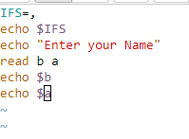

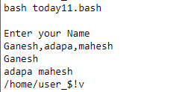

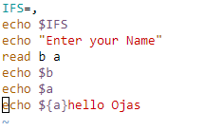

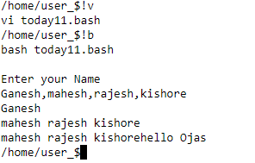

Execution:

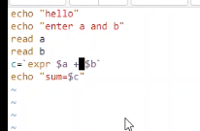

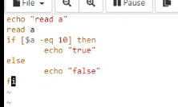

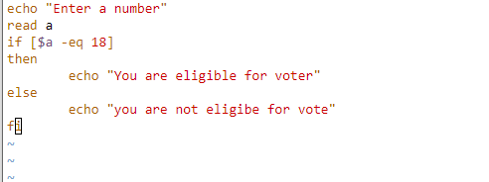

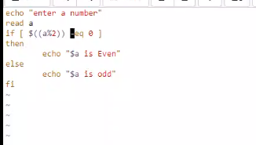

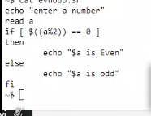

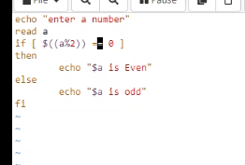

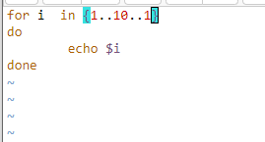

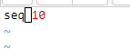

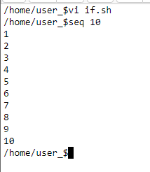

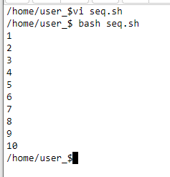

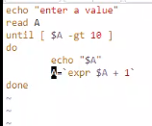

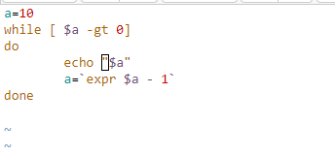

**Today(11/09/2020):**

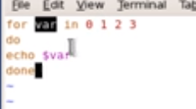

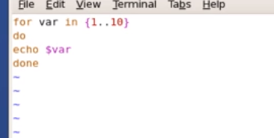

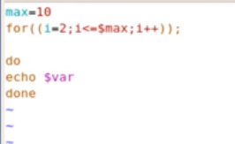

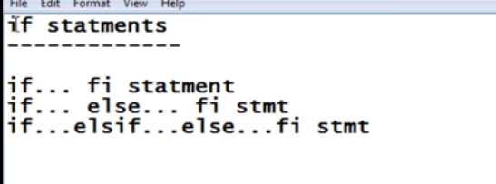

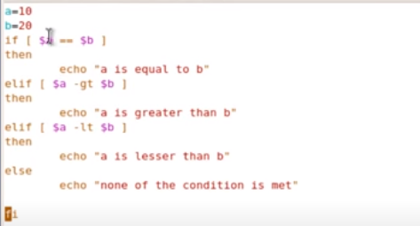

**Today(12/09/2020):**

**Loops in Unix using Shell Scripting:**

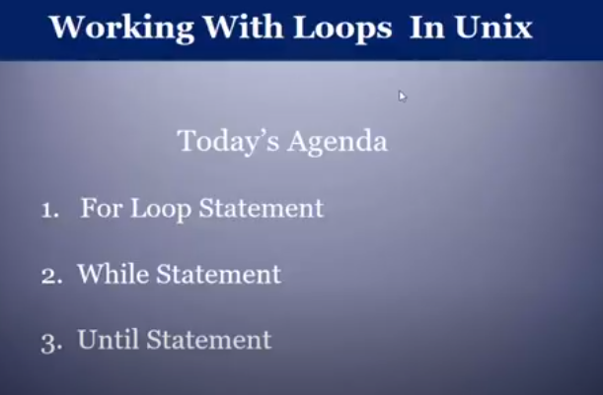

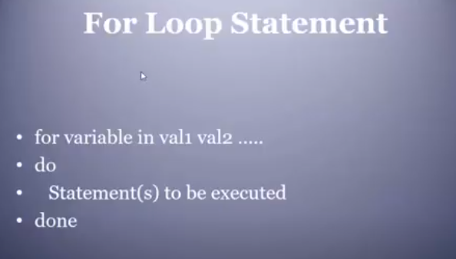

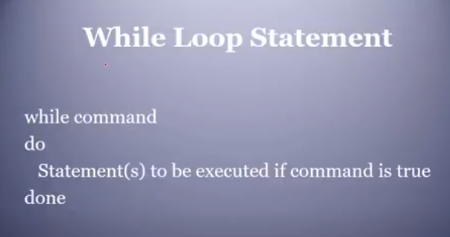

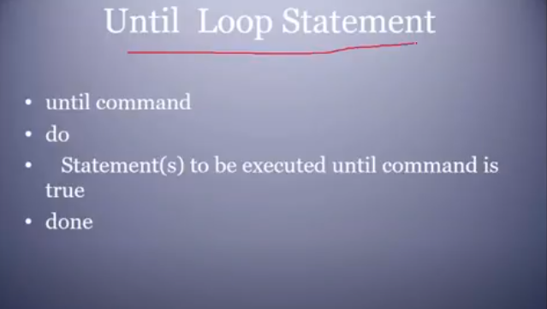

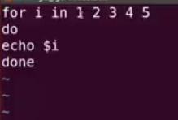

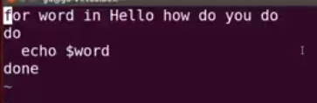

Display the files present in the current directory:

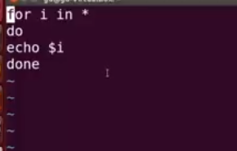

While:

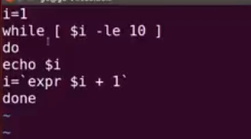

Until loop example:

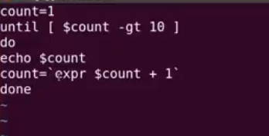

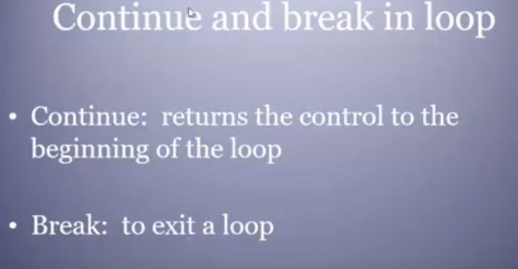

Continue:

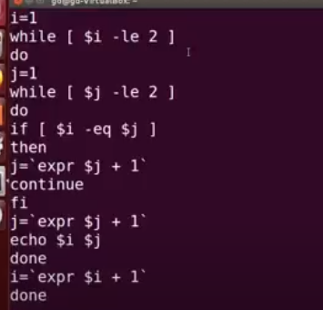

Break:

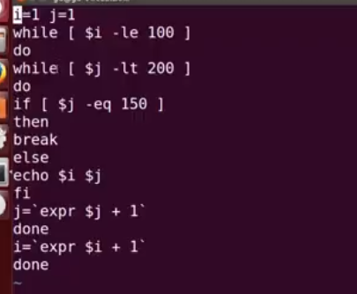

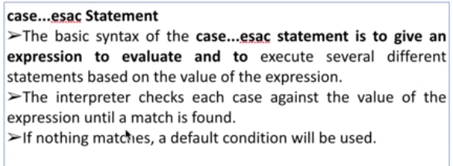

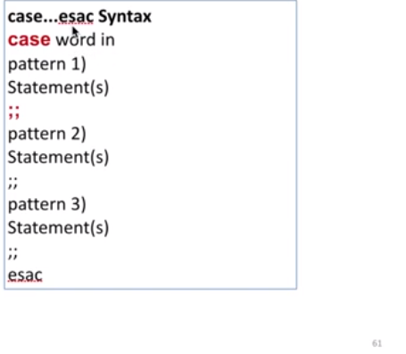

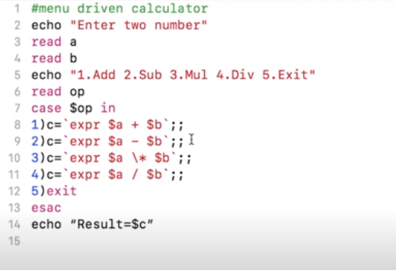

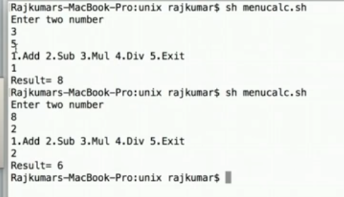

Today

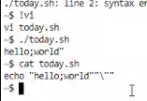

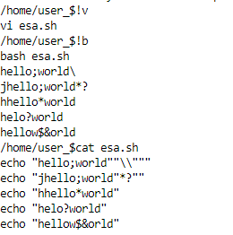

Array:

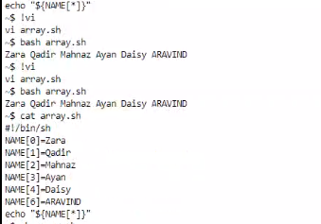





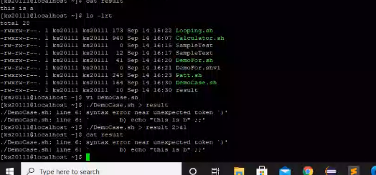

Output Redirecting:

Command: ./simple.sh > result

Error Redirecting:

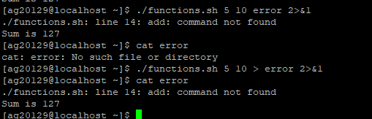

Functions in Different Formats:

We can use in diffrent ways:

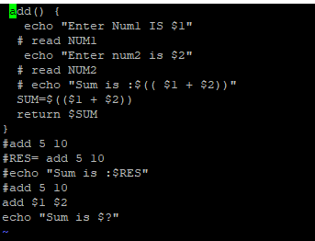

**Funcation -1 way :**

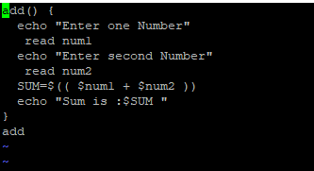

**Output:**

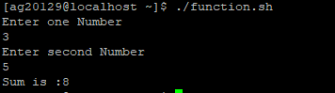

**Function 2-way:**

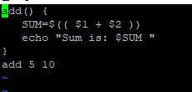

**Output:**

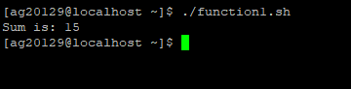

**Function 3-way:**

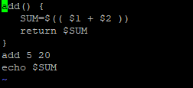

**Output:**

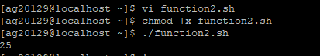

**Function 4-way:**

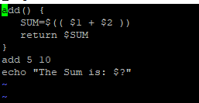

Output:

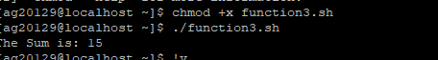

**Today(15/09/2020):**

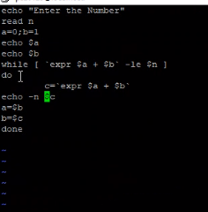



heredoc.sh

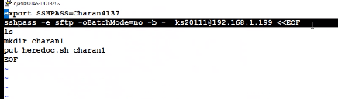

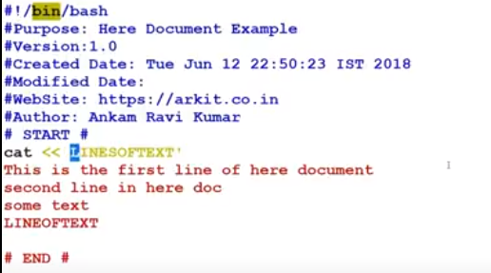

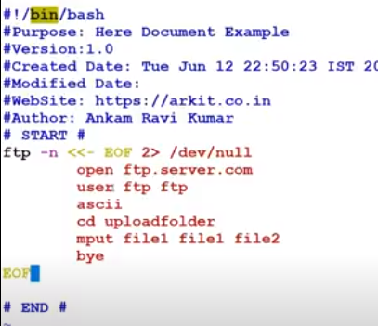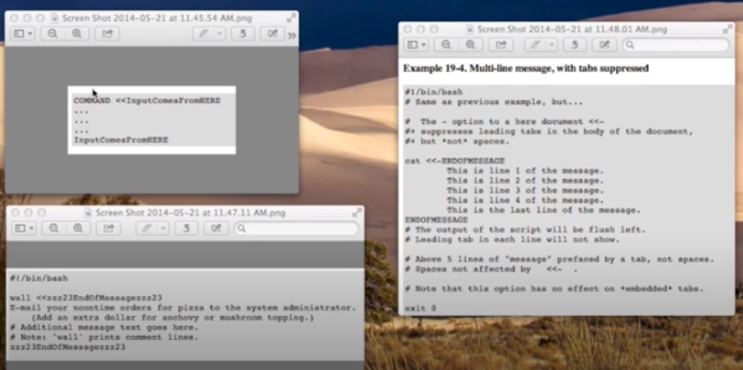

**Heredoc:**

In **Bash** and other shells like Zsh, a Here document (**Heredoc**) is a type of redirection that allows you to pass multiple lines of input to a **command**. The first line starts with an optional **command** followed by the special redirection operator << and the delimiting identifier.

Crontab:

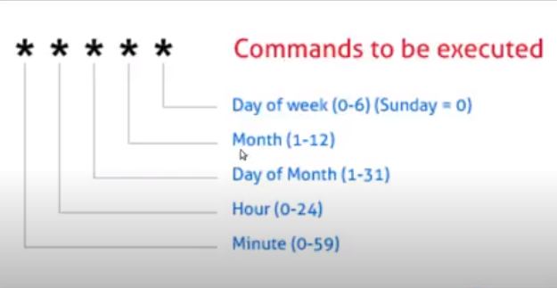

**Today(16/09/2020):**

Toconnect and tranfer some files using sftp:

Sftp using dochere:

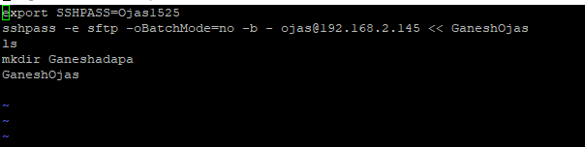

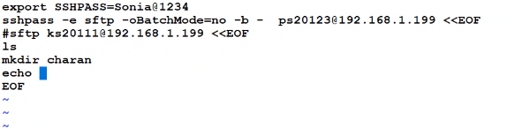

**To connect with mysql:**

**Command:**

mysql -u root -p'Xp1o0^Vf9w5#X' -h 192.168.1.69 -P 3306 -D ojasinv-it

**Heredocument is :**

**Vi mysql.sh:**

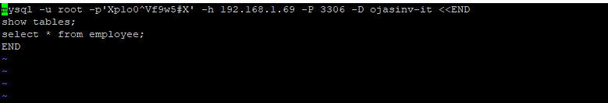

Today(17/09/2020):

Hwo to connect first time sftp:



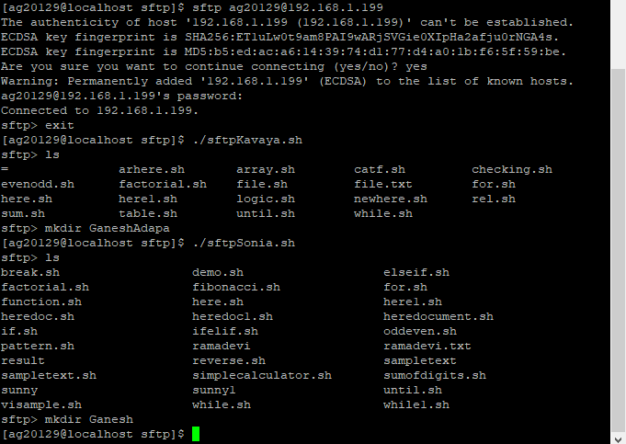

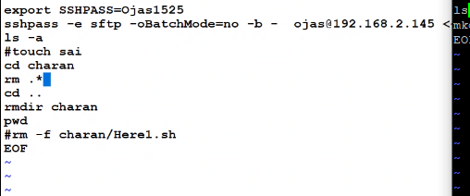



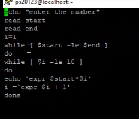

1.Write a program to count no.of characters,words,spaces in a file ?

2. w.a read two strings and ? compare two inputs by the user ?

3. to find out the location of input character into an input. ?

4.write a shell script to translate the content of a file into upper case, where file name is entered through command line.

5. perform following actions:

1)Moving shell files from PWD to specified directory.  
2)Write a shell script to find out the location of an input character into an input string.  
3)Write a shell script to count the number of characters, words, spaces in a given text.  
4)Write a shell script to translate the contents of a file into UPPER CASE,  
where file name is entered through command line.  
5)Write a shell script to perform following tasksa. Display the present working directory.  
b. Clear the screen.  
c. Display the current date.  
d. Make a directory with its -directory d1.  
e. Change the directory to the directory having sub directory d1.

[4:40 PM] Arun Kumar Alampally

Question:

Write a shell script to print all the lines of the input which are in the given range. The first line of the input contains two integers start and end separated by space. You have to print all the lines of the file input which are in the range of [start, end].

**Solution:**

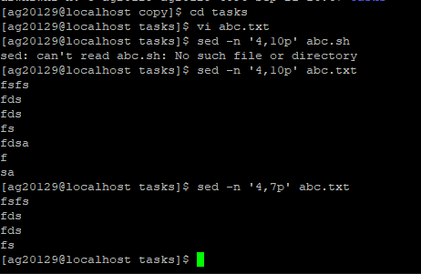

1. **Moving shell files from PWD to specified directory.**

**Solution:**

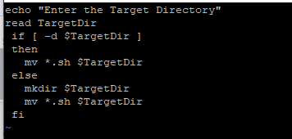

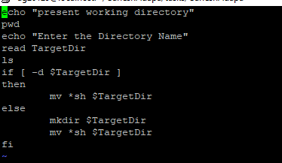

2)Write a shell script to print all the lines of the input which are in the given range.  
The first line of the input contains two integers start and end separated by space.  
You have to print all the lines of the file input which are in the range of [start, end].

1. Write a shell script to translate the contents of a file into UPPER CASE,  
   where file name is entered through command line.  
   Solution:

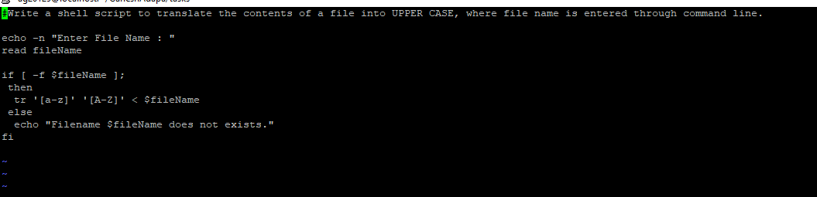

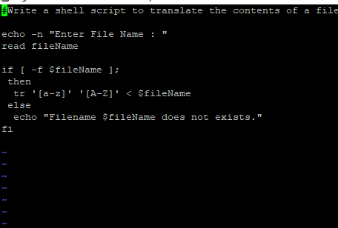

1. Write a shell script to perform following tasksa.

a.Display the present working directory.  
b. Clear the screen.  
c. Display the current date.  
d. Make a directory with its -directory d1.  
e. Change the directory to the directory having sub directory d1.

1. Display the present working directory.

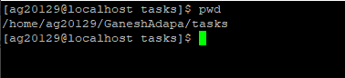  
b. Clear the screen.

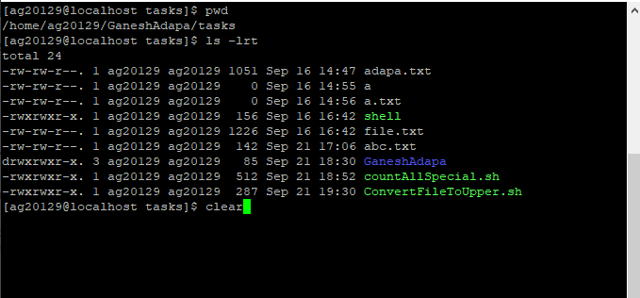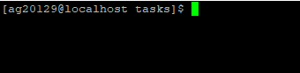

c. Display the current date.

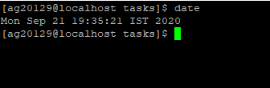  
d. Make a directory with its -directory d1.

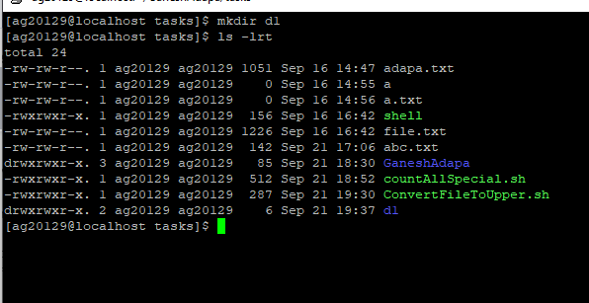  
e. Change the directory to the directory having sub directory d1.

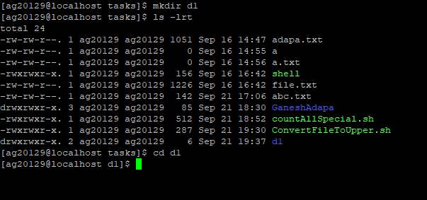

Today(22/09/2020):

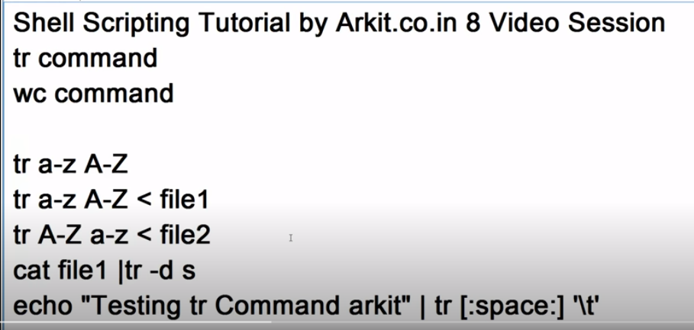

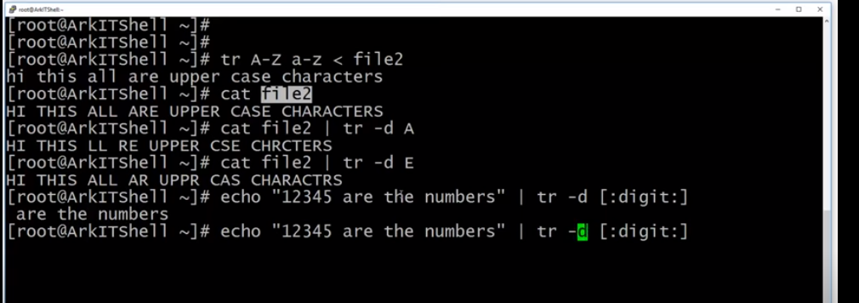

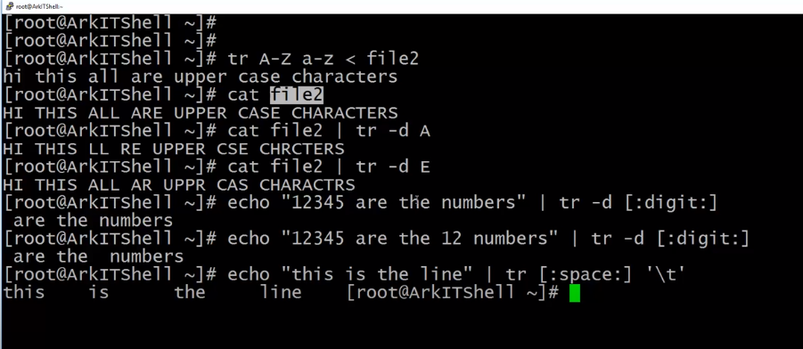

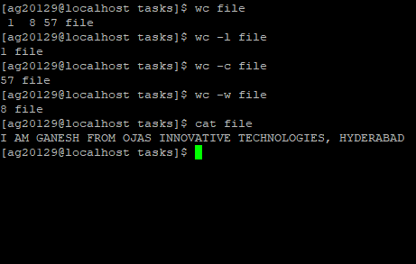

Tr:

Translate or delete

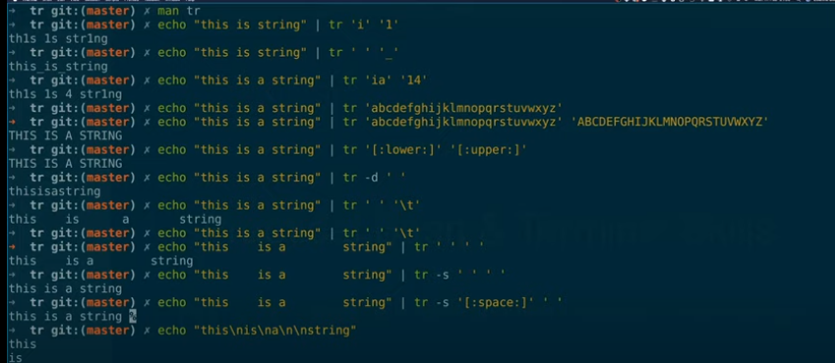

Write a shell script that removes all the special characters in the given file

Assume all the below characters are special

! @ # $ % ^ & * ( ) _ - + = { } [ ] ; : ' " ` / > ? . , < ~ | \

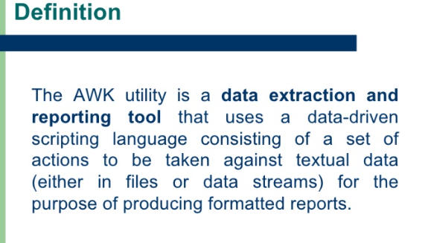

Code:

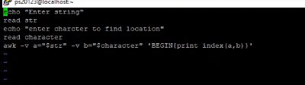

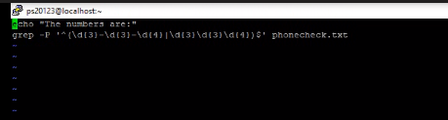

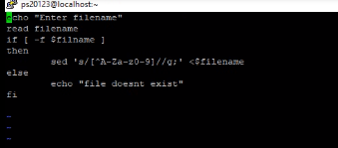

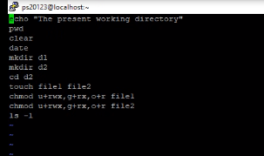

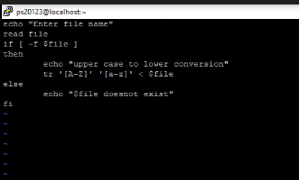

#Write a shell script to translate the contents of a file into UPPER CASE, where file name is entered through command line.

echo -n "Enter File Name : "

read fileName

if [ -f $fileName ];

then

tr '[a-z]' '[A-Z]' < $fileName

else

echo "Filename $fileName does not exists."

fi

**Count:**

echo Enter the filename

read file

w=`cat $file | wc -w`

c=`cat $file | wc -c`

l=`cat $file | wc -l`

s=`grep -o ' ' $file | wc`

echo Number of characters in $file is $c

echo Number of words in $file is $w

echo Number of lines in $file is $l

echo Number of spaces in $file is $s

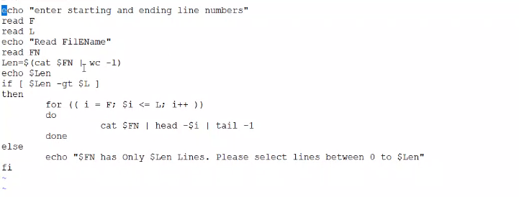

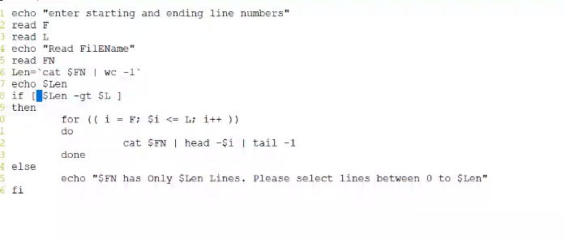

filename=$1

if [ -f $filename ]

then

read start

read end

i=1

while [ $i -le $end ]

do

read -r line

if [ $i -lt $start ]

then

continue;

else

echo $line

fi

start=`expr $start + 1`

i=`expr $i + 1`

done < $filename

fi

echo "Enter the file Name"

read filename

if [ -f $filename ]

then

echo "The numbers are:"

grep -P '^(\d{3}-\d{3}-\d{4}|\d{3}\d{3}\d{4})$' $filename

else

echo "File Not Exits"

fi

Important Idm Questions and Answers

1. **Moving shell files from PWD to specified directory.**

**Code:**

echo "present working directory"

pwd

read TargetDir

ls

if [ -d $TargetDir ]

then

mv *sh $TargetDir

else

mkdir $TargetDir

mv *sh $TargetDir

fi

**2)Write a shell script to find out the location of an input character into an input string.  
Code:**

echo "Enter string"

read str

echo "enter charcter to find location"

read character

awk -v a="$str" -v b="$character" 'BEGIN{print index(a,b)}'

**3)Write a shell script to count the number of characters, words, spaces in a given text.**

**Code:**

echo Enter the filename

read file

if [ -f $file ]

then

w=`cat $file | wc -w`

c=`cat $file | wc -c`

l=`cat $file | wc -l`

s=`cat $file | grep -o " "| wc -l)`

echo Number of characters in $file is $c

echo Number of words in $file is $w

echo Number of lines in $file is $l

echo Number of spaces in $file is $s

else

echo "File not Exit"

fi

**Or:**

echo "Enter a file name"

read file

if [ -z $file ]

then

echo "File is Empty"

else

echo "Number of words in File are: $(cat $file | wc -w)"

echo "Number of Lines in File are: $(cat $file | wc -l)"

echo "Number of White spaces in File are: $(cat $file | grep -o " "| wc -l)"

echo "Number of Charcaters in File : $(wc -c $file)"

fi

1. **Write a shell script to translate the contents of a file into UPPER CASE,  
   where file name is entered through command line.  
   Code:**

echo "Enter filename"

read filename

if [ -f $filname ]

then

sed 's/[^A-Za-z0-9]/ /g;' <$filename

else

echo "file doesnt exist"

fi

**5)Write a shell script to perform following tasksa. Display the present working directory.  
b. Clear the screen.  
c. Display the current date.  
d. Make a directory with its -directory d1.  
e. Change the directory to the directory having sub directory d1.  
f. Create two files (say file1 & file2) within this.  
g. Provide appropriate security options to these files.  
h. List the contents of directory**

**Code:**

echo "The Present Working Diretory"

clear

pwd

date

cal

mkdir d1

mkdir d2

cd d2

touch file1 file2

chmod u+rwx,g+rx,o+r file1

chmod u+rwx,g+rx,o+r file2

ls -l

**6) Write a shell script to print all valid phone numbers.**

**Input a text file to the script that contains list of phone numbers (one per line).**

**Valid phone number must appear in one of the following two formats and all other formats should be shown as invalid**

**xxxxxxxxxx**

**xxx-xxx-xxxx**

**Code:**

if [ $# -lt 1 ]

then

echo "Invalid no of arguments please pass atleat one argument"

else

FILE=$1

LOF=`cat $FILE | wc -l`

fi

if [ $LOF -lt 1 ]

then

exit

else

while [ $LOF -ge 1 ]

do

read LINE

if [[ $LINE == [0-9][0-9][0-9][0-9][0-9][0-9][0-9][0-9][0-9][0-9] ]]

# if [[ ($LINE == [0-9]{10}) || ($LINE == [0-9]{3}[-][0-9]{3}[-][0-9]{4}) ]]

then

echo "$LINE is Valid"

else

echo "$LINE is In-Valid"

fi

LOF=$(($LOF - 1))

done < $FILE

fi

**or**

echo "Enter the file Name"

read filename

if [ -f $filename ]

then

echo "The numbers are:"

grep -P '^(\d{3}-\d{3}-\d{4}|\d{3}\d{3}\d{4})$' $filename

else

echo "File Not Exits"

fi

**7) Write a shell script that removes all the special characters in the given file**

**Assume all the below characters are special**

**! @ # $ % ^ & * ( ) _ - + = { } [ ] ; : ' " ` / > ? . , < ~ | \**

**Code:**

echo "Enter filename"

read filename

if [ -f $filname ]

then

sed 's/[^A-Za-z0-9]/ /g;' <$filename

else

echo "file doesnt exist"

fi

W.a duplicate copy of a specified file through command line

echo "Enter filename"

read filename

if [ -f $filname ]

then

sed 's/[^A-Za-z0-9]/ /g;' <$filename

else

echo "file doesnt exist"

fi

**Sftp sending file:**

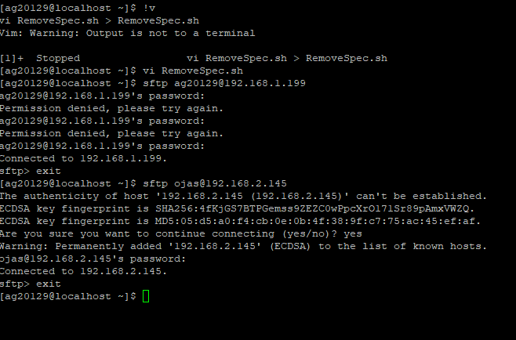

Sponge command:

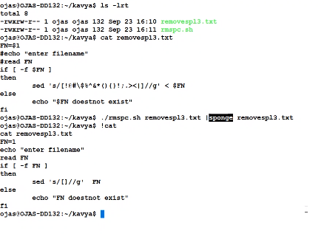

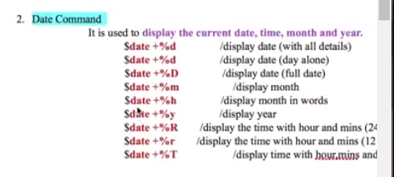

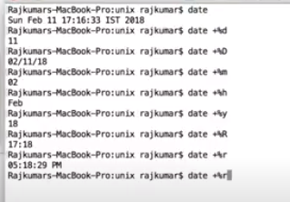

**Tasks(23/09/2020) :**

1)Write a shell script to print the characters of an input string into reverse order.

2)Write a shell script to find out the location of an input character into an input string.

3)Write a shell script to remove all words that occur more than once in a list.

4)Write a shell script to take backup of all c files.

5)Write a program in UNIX to accept range of months and display calendar within that range.

6)To find out the greatest and smallest element of an array.

7)Write a shell script that takes a command-line argument and reports whether it is a directory, a file, or

something else.

8)Write a shell script to display a three digit number in English words.

9)Moving shell files from PWD to specified directory.

10) To print all the files and total number of files in given directory.

11)Create a file containing a command which will delete all files in ˜/tmp/ when it is run. Make that script be run every 5secs.

1)Write a shell script to print the characters of an input string into reverse order.

**Code:**

echo "Enter the String"

read STRING

echo $STRING | rev

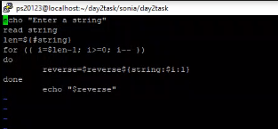

1. **Write a shell script to find out the location of an input character into an input string.**

**Code:**

echo "Enter the Stirng"

read STRING

echo "Enter Charater "

read CHAR

awk -v a="$STRING" -v b="$CHAR" 'BEGIN{print "The Location is :" index(a,b)}'

**3)Write a shell script to remove all words that occur more than once in a list.**

**About xargs command:**

****Xargs**** is a great command that reads streams of data from standard input, then generates and executes command lines; meaning it can take output of a command and passes it as argument of another command. If no command is specified, xargs executes echo by default. You many also instruct it to read data from a file instead of stdin.

**Code:**

echo "Enter the Stirng"

read STRING

echo "$STRING" | xargs -n1 | sort -u | xargs

**4)Write a shell script to take backup of all c files.**

**Code:**

#!/bin/sh  
echo "Enter the file name"  
read FN  
if [ -f $FN ]  
then  
         cp $FN $FN.bak  
        echo "File backed up successfully"  
else  
        echo "File does not exists"  
fi

**5)Write a program in UNIX to accept range of months and display calendar within that range.**

**Code:**

echo "enter starting month"

read start

echo "enter ending month"

read end

echo "enter year"

read year

while [ $start -le $end ]

do

cal $start $year

start=`expr $start + 1`

done

**6)To find out the greatest and smallest element of an array.**

**Code:**

echo "enter size of an array"

read n

for((i=0;i<n;i++))

do

echo " enter $((i+1)) number"

read nos[$i]

done

echo "number entered are"

for((i=0;i<n;i++))

do

echo ${nos[$i]}

done

small=${nos[0]}

greatest=${nos[0]}

for((i=0;i<n;i++))

do

if [ ${nos[$i]} -lt $small ];

then

small=${nos[$i]}

elif [ ${nos[$i]} -gt $greatest ];

then

greatest=${nos[$i]}

fi

done

echo "smallest number in an array is $small"

echo "greatest number in an array is $greatest"

**7)Write a shell script that takes a command-line argument and reports whether it is a directory, a file, or**

**something else.**

**Code:**

INPUT=$1

if [ -f $INPUT ]

then

echo "File"

elif [ -d $INPUT ]

then

echo "Directory"

else

echo "Something else"

fi

**8)Write a shell script to display a three digit number in English words.**

**Code:**

echo -n "Enter number: "

read n

len=$(echo $n | wc -c)

len=$(( $len - l ))

echo "your number $n in words:"

for (( i=1; i<=$len; i++ ))

do

digit=$(echo $n | cut -c $i)

case $digit in

0)echo -n "Zero";;

1)echo -n "one";;

2)echo -n "two";;

3)echo -n "three";;

4)echo -n "four";;

5)echo -n "five";;

6)echo -n "six";;

7)echo -n "seven";;

8)echo -n "eight";;

9)echo -n "nine";;

esac

done

echo

**9)Moving shell files from PWD to specified directory.**

**Code:**

echo "present working directory"

pwd

read TargetDir

ls

if [ -d $TargetDir ]

then

mv *sh $TargetDir

else

mkdir $TargetDir

mv *sh $TargetDir

fi

1. **To print all the files and total number of files in given directory.**

**Code:**

echo "Enter the Directory"

read DIR

if [ -d $DIR ]

then

cd $DIR

echo "Directory $DIR Files are:"

find -type f

echo "Total Number of Files are : `find -type f | wc -l`"

else

echo "Directory is Not Found"

fi

**11)Create a file containing a command which will delete all files in ˜/tmp/ when it is run. Make that script be run every 5secs.**

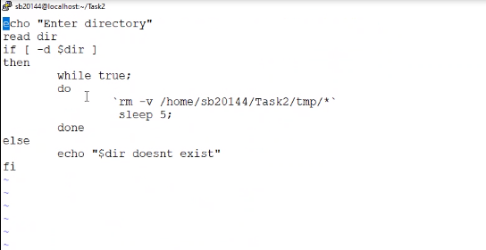

**LocationOfCharacterInString:**

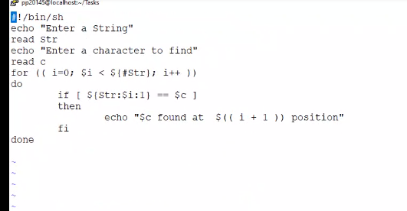

**Today(25/09/2020):**

1). Write a shell script to calculate the net salary of an employee in a particular month considering various

allowances (TA, DA, HRA) and deductions (INCOME TAX, PROVIDEND FUND) as:

a. TA=15 percent of basic salary

b. DA=2 percent of basic salary

c. HRA=10 percent of basic salary

d. INCOME TAX=5 percent of salary

e. PROVIDEND FUND=10 percent of salary

2)Write a shell script to find out the factorial of an input.

3)Write a shell script to generate the series of even number from 0 to n. 0 2 4.....n

4)Write a shell script to find out the sum of series 1+2+3+………….n, where n is input by the user

5)Write a shell script to generate the series 1, 5, 2, 10, 3, 15,………….50.

6)The marks obtained by a student in two different subjects are input through the keyboard. The student

gets a division as per the following rules. (Using elif clause).

if percentage greater than or equal to 60 get First division

if percentage greater than or equal to 50 or less than 60 get Second division

if percentage greater than or equal to 40 or less than 50 get Third division

if percentage less than 40 Fail.

**Solutions:**

1). Write a shell script to calculate the net salary of an employee in a particular month considering various

allowances (TA, DA, HRA) and deductions (INCOME TAX, PROVIDEND FUND) as:

a. TA=15 percent of basic salary

b. DA=2 percent of basic salary

c. HRA=10 percent of basic salary

d. INCOME TAX=5 percent of salary

e. PROVIDEND FUND=10 percent of salary

2)Write a shell script to find out the factorial of an input.

**Code:**

echo "Enter any Number"

read NUM

i=1

fact=1

while [ $i -le $NUM ]

do

fact=$(($fact * $i))

i=`expr $i + 1`

done

echo "The Factorial of $NUM is : $fact"

3)Write a shell script to generate the series of even number from 0 to n. 0 2 4.....n

**Code:**

echo "Enter the Ending series of Even "

read end

echo "The Even Numbers From 0 to $end are : "

for (( i =0; i <= $end; i++ ))

do

if [ $((i%2)) -eq 0 ]

then

echo $i

fi

done

4)Write a shell script to find out the sum of series 1+2+3+………….n, where n is input by the user

**Code:**

echo "Enter the Ending Number of Series to count Sum of All"

read end

i=0

count=0

while [ $i -le $end ]

do

count=`expr $count + $i`

i=`expr $i + 1`

done

echo $count

5)Write a shell script to generate the series 1, 5, 2, 10, 3, 15,………….50.

6)The marks obtained by a student in two different subjects are input through the keyboard. The student

gets a division as per the following rules. (Using elif clause).

if percentage greater than or equal to 60 get First division

if percentage greater than or equal to 50 or less than 60 get Second division

if percentage greater than or equal to 40 or less than 50 get Third division

if percentage less than 40 Fail.

**Code:**

echo "Enter first Subject Marks "

read MARKS1

echo "Enter Second Subject Marks "

read MARKS2

OBT=`expr $MARKS1 + $MARKS2`

RES=$(( $OBT * 100 ))

PER=$(( $RES / 200 ))

echo $PER

if [ $PER -lt 40 ]

then

echo "Fail"

elif [ $PER -ge 40 -a $PER -lt 50 ]

then

echo "Third Division"

elif [ $PER -ge 50 -a $PER -lt 60 ]

then

echo "Second Division"

else

echo "First Division"

fi

**Today(07/09/2020):**

**Creating Jar files for core java programs only:**

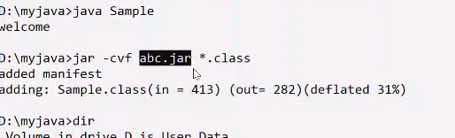

For all:

Jar -cvf abc.jar .

For web applications use War file.

